**CMPE273: Lab 2**

**Name: Suraj Bhukebag**

**Student Id: 011809837**

Dropbox Application

Introduction:

Goal: To develop a prototype of Dropbox to demonstrate distributed system design and architecture that is scalable, fine-tuned and highly robust in nature using Kafka messaging service and MongoDB.

System Design:

Application is developed as a n-tier application that has client layer, middleware layer and data layer.

**Client Layer:** User interface is built using React framework and Redux is used for maintaining state in the UI. Session is maintained with the help of express-sessions module provided by npm. UI makes use of bootstrap for responsive design.

**Middleware:** The middleware layer of dropbox application is divided into two parts.

First part is set of REST APIs that are exposed to a specific domain. This part is responsible for just mapping the REST API, collecting the request data and making another call to a different server in the form of messages. This part of middleware is built on Node.js and Express stack which provides async, non-blocking way of serving requests which is very important in scalability. Also, express session modules help server to maintain sessions to identify what requests to serve based on cookies.

Second part of middleware is Kafka backend that has set of consumers that are waiting for messages of specific topic. Kafka is a messaging broker that manages messages between Node backend and Kafka Backend. Node backend and kafka back end both works on Pub/Sub model in which each entity is subscribed to specific topic and is notified whenever new message is available. Both these entities act as Producer and Consumer. Kafka backend is implemented as Node application. Kafka-node is a module that provide communication with Kafka messaging queue.

High level architecture of Middlaware:

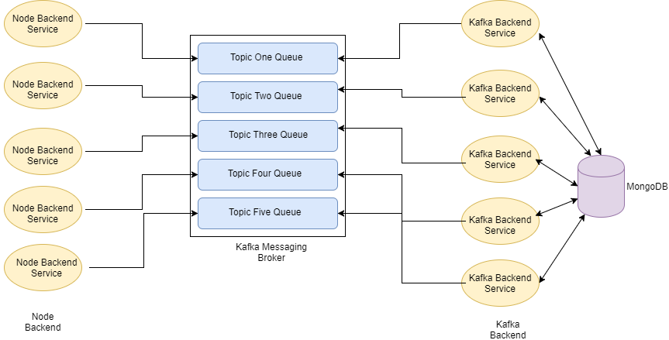

**Data Layer:** MongoDB is used as data store which is a NoSql datastore that stores data in the form of key value pairs. Each entry is called as document in MongoDB. Node provides support for MongoDB using mongo and mongoose packages. Mongoose is object modelling for MongoDB that provides connection pooling by default for better performance. Also, custom connection pooling is implemented and performances are measured using Jmeter.

**Database Schema of Dropbox:**



Technology Stack:



 

**Screenshots of Application**

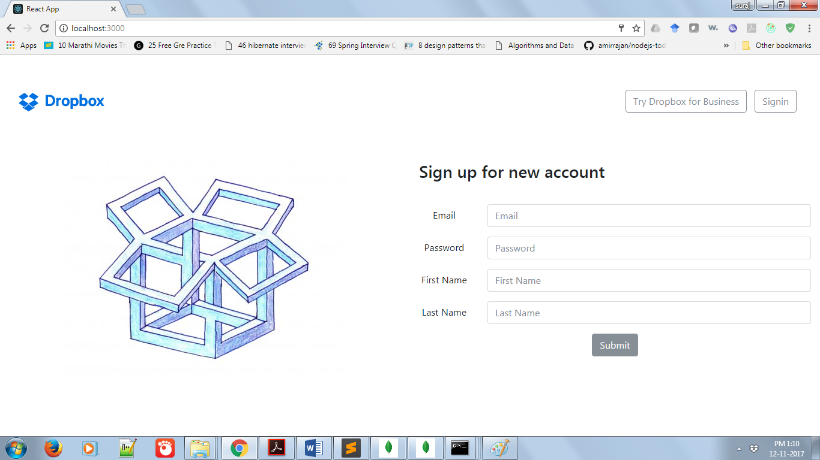

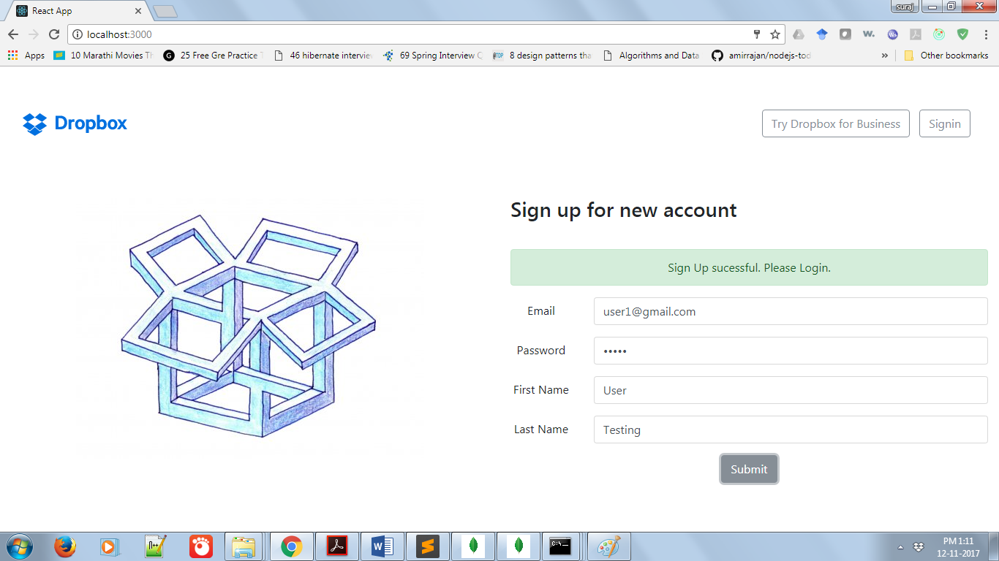

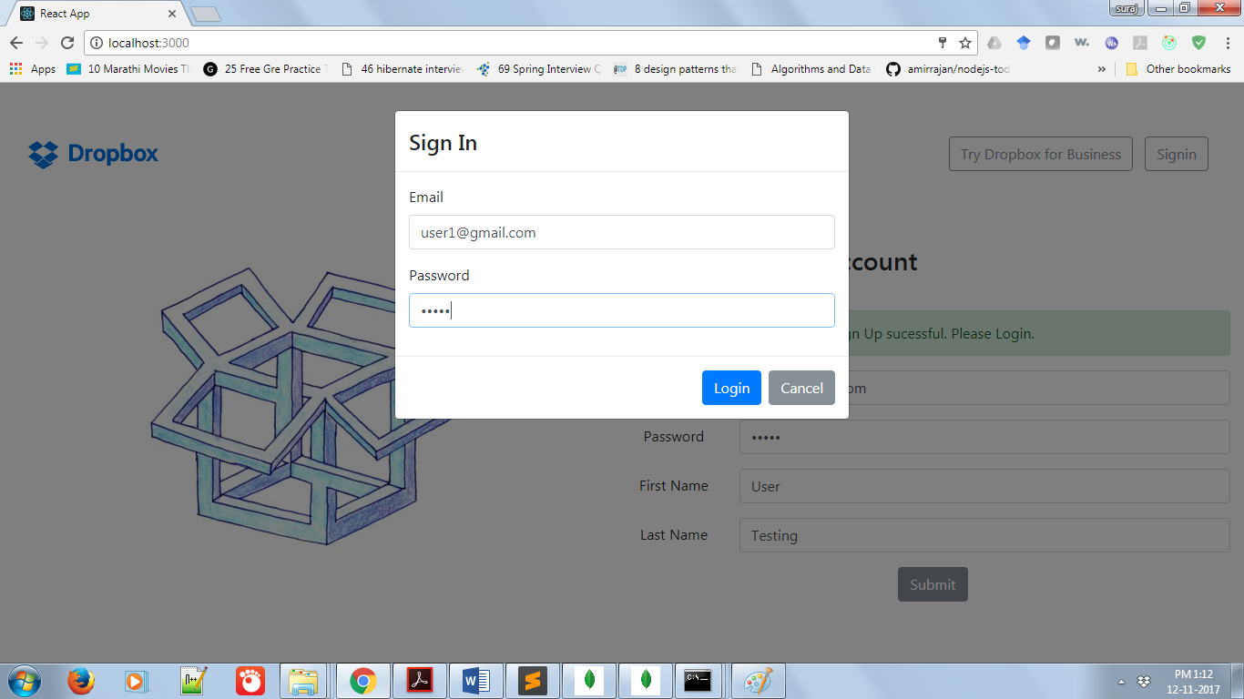

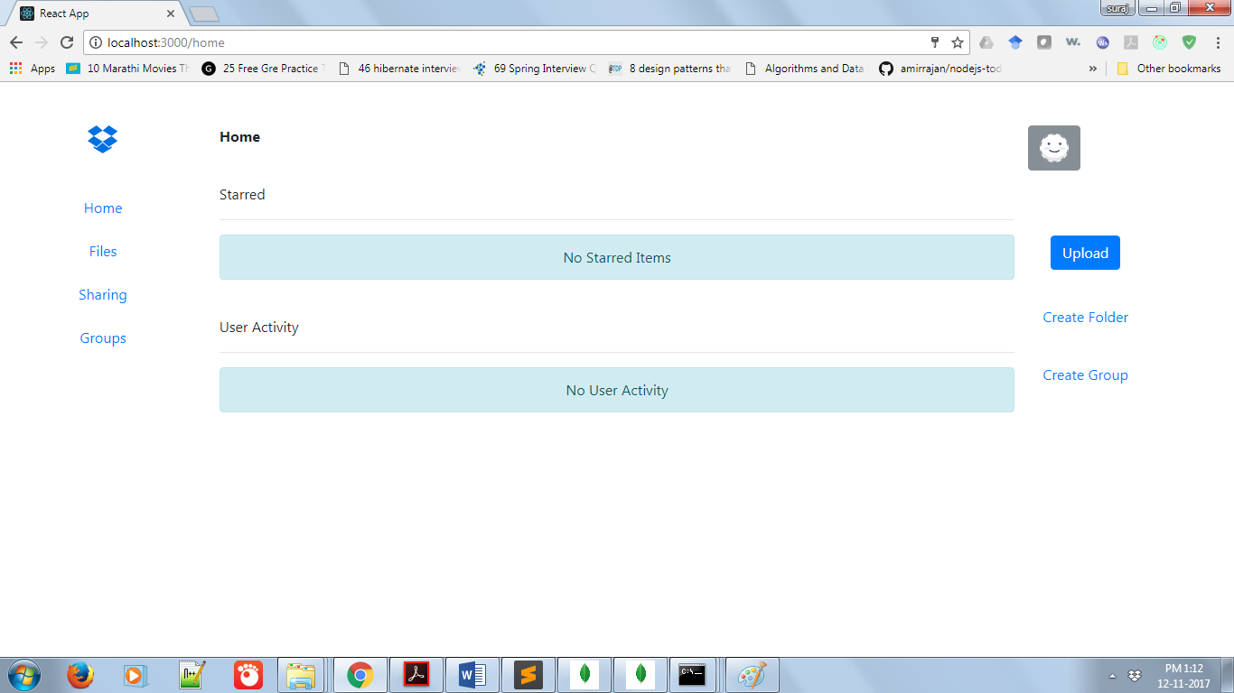

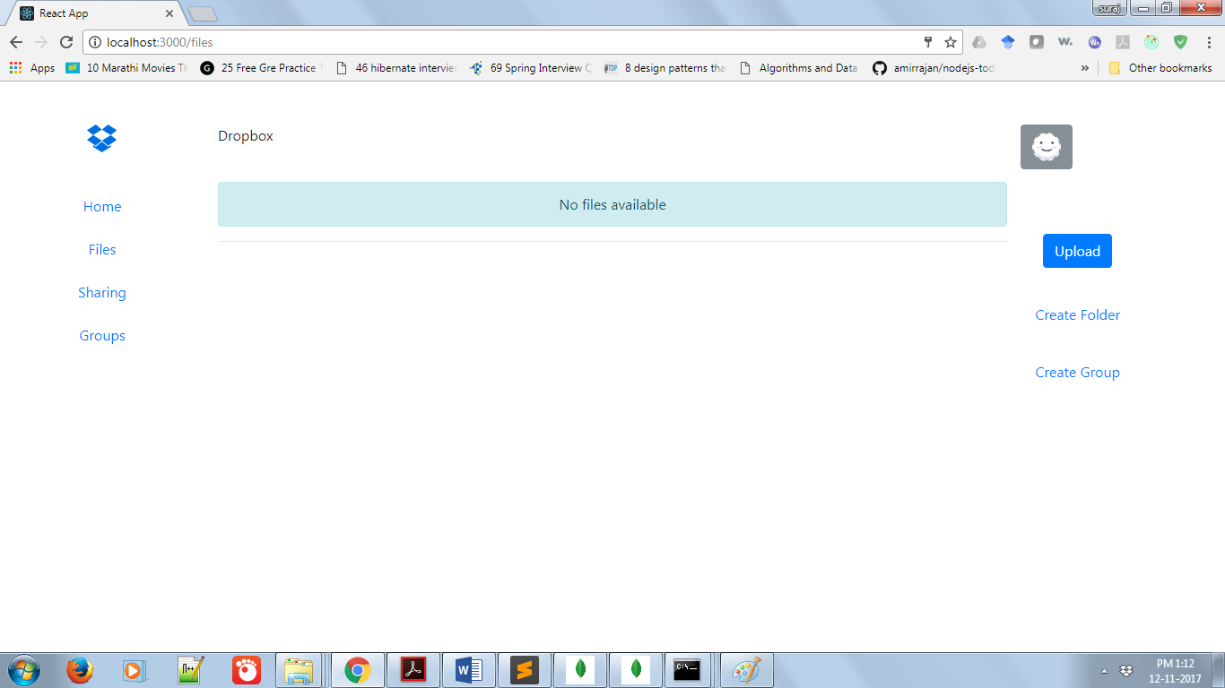

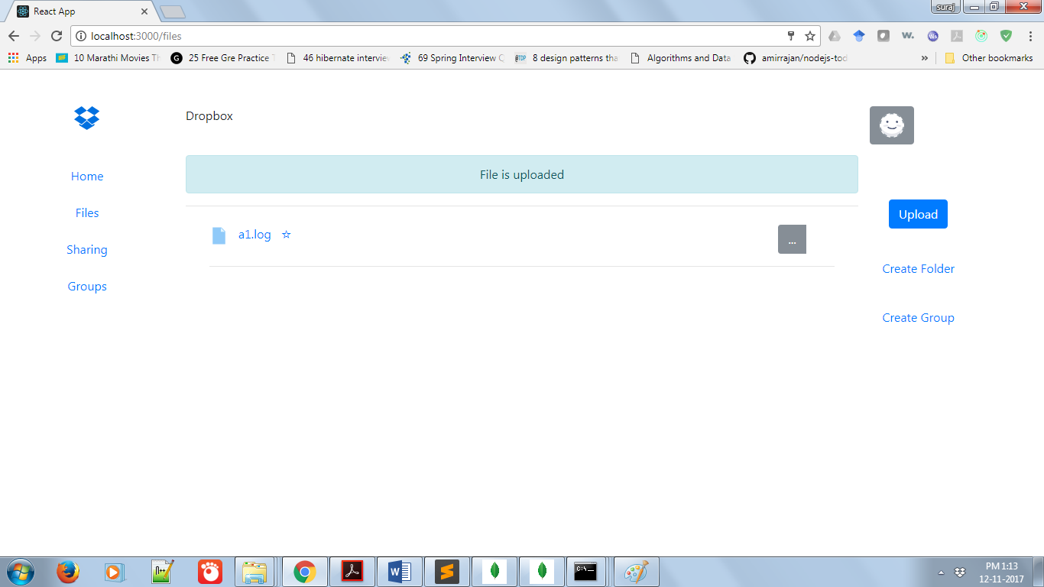

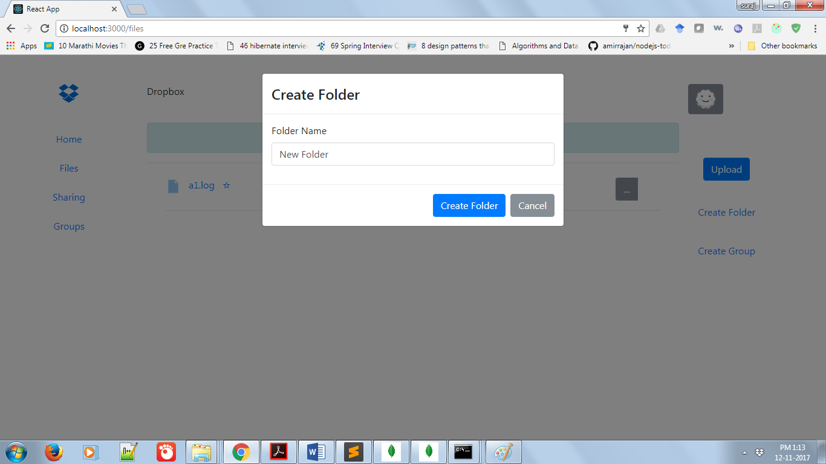

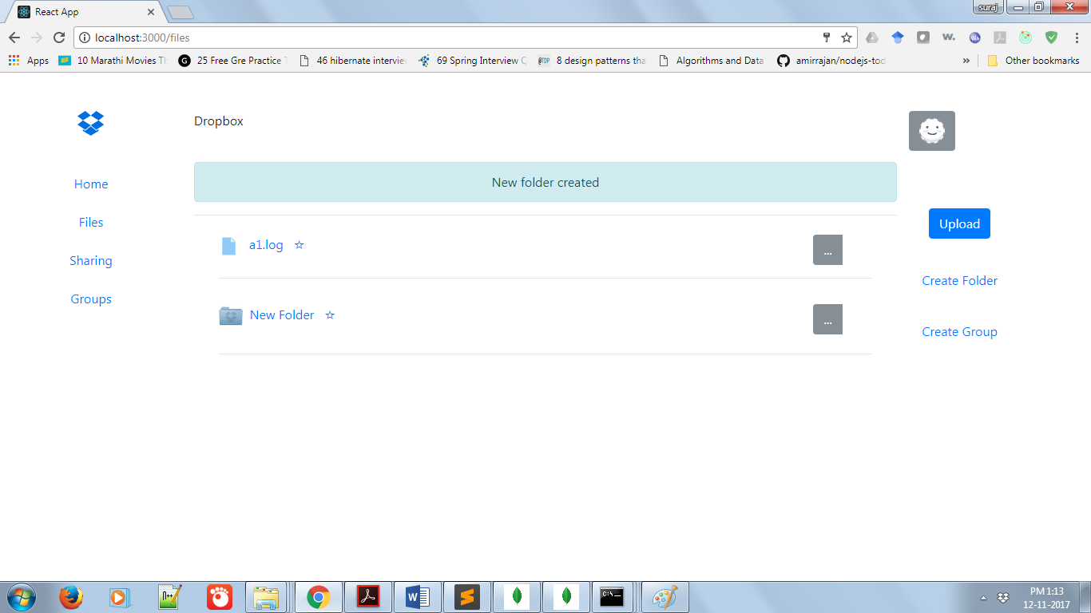

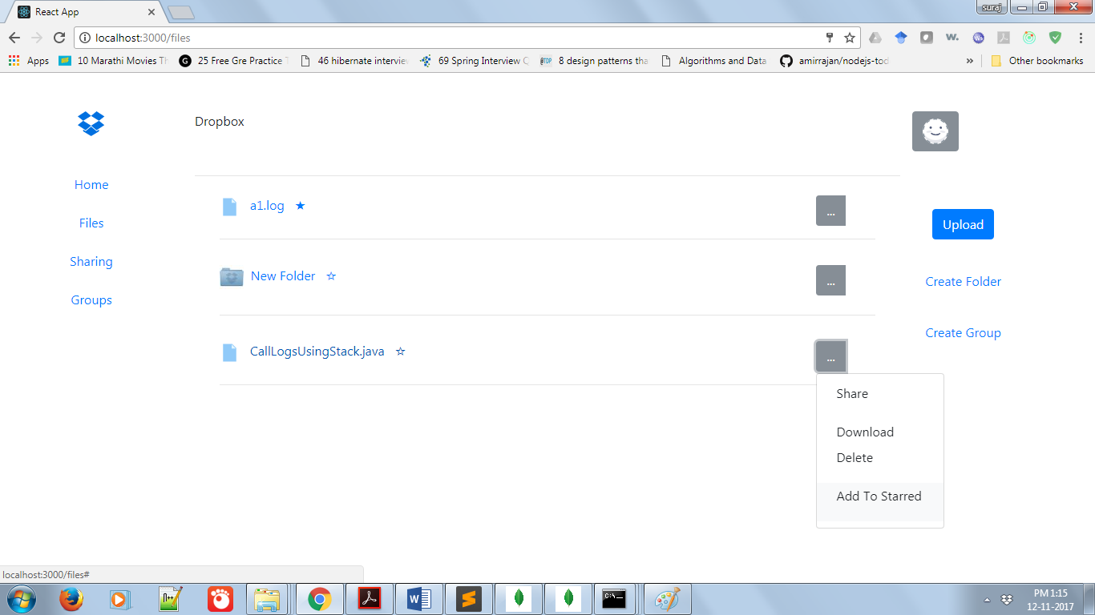

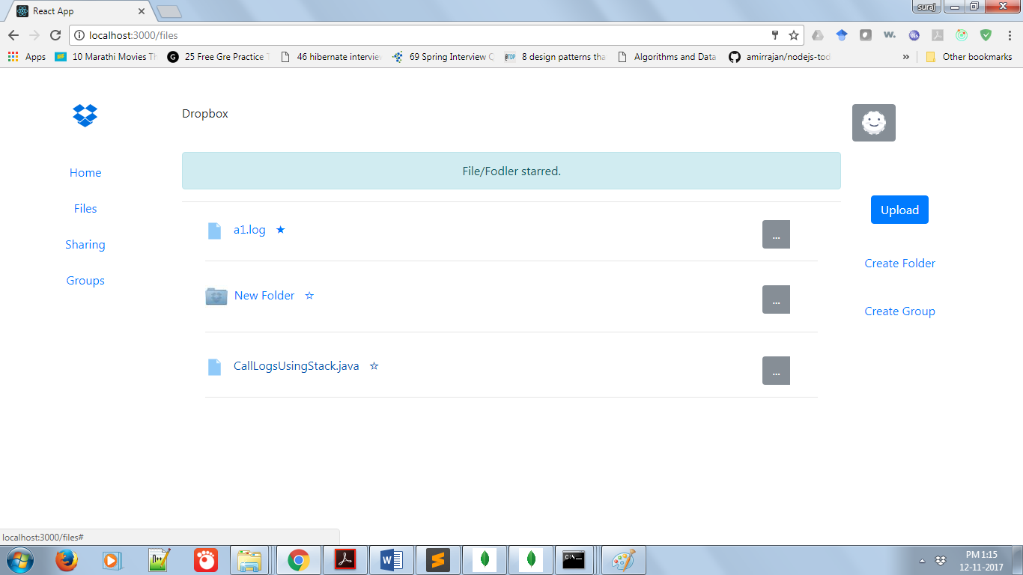

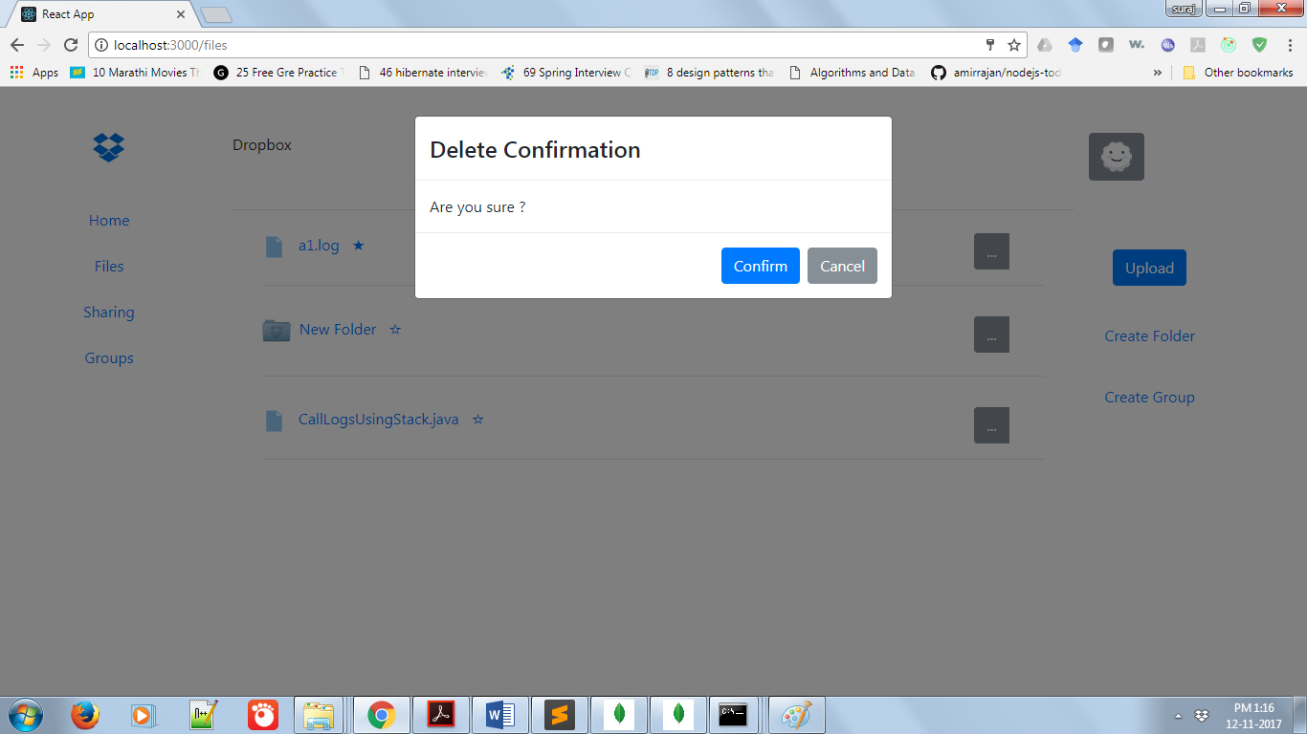

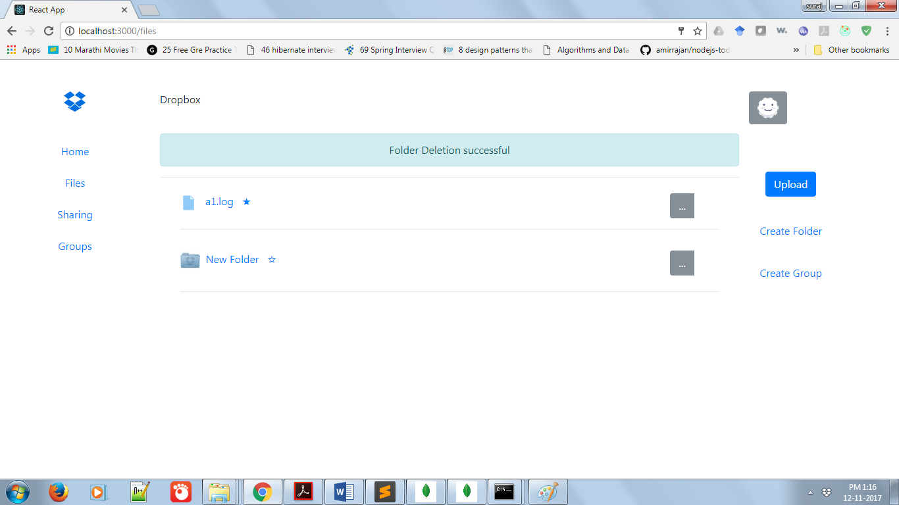

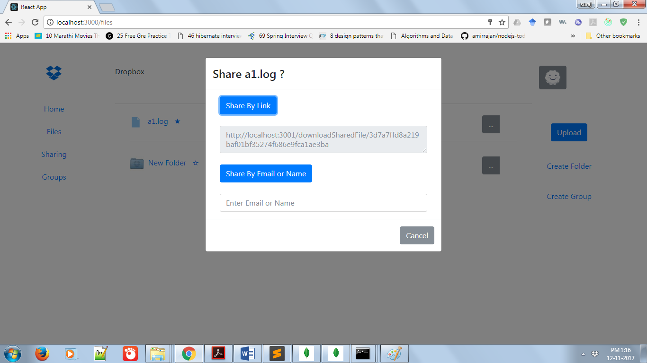

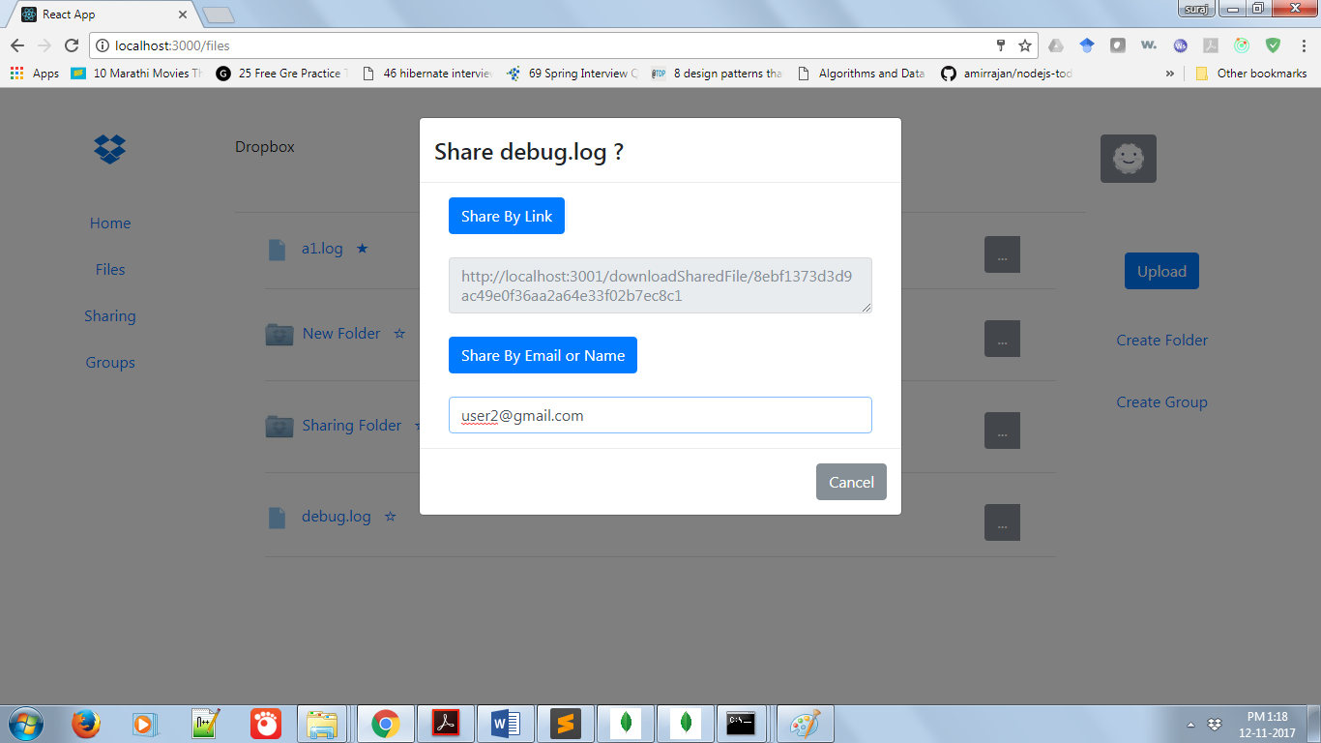

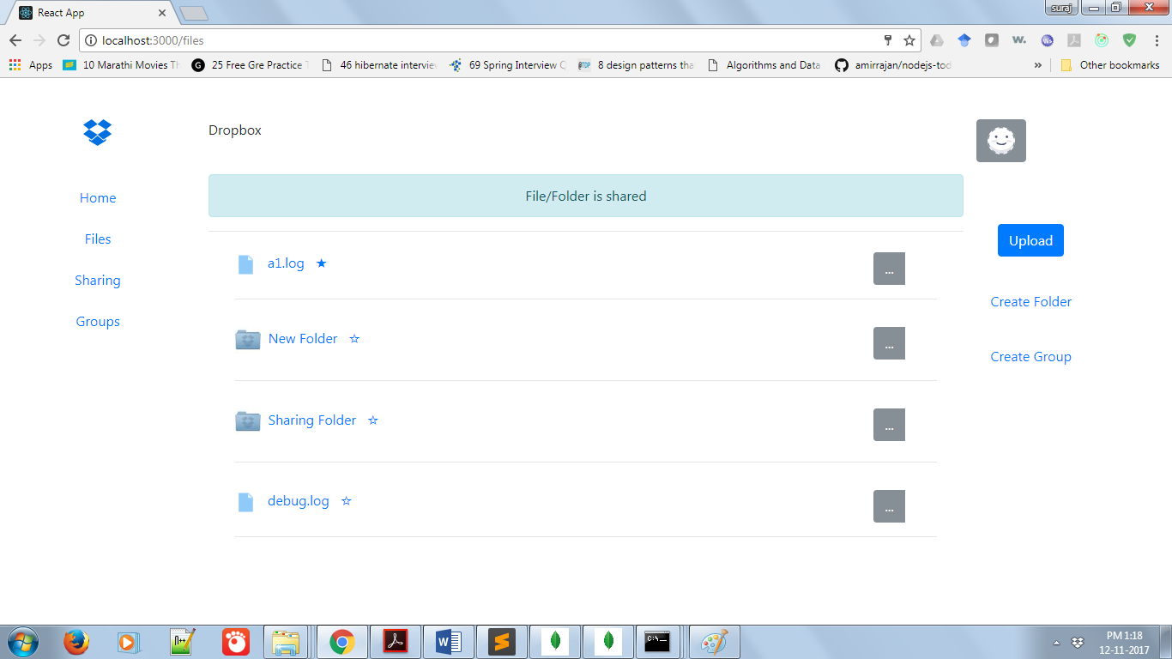

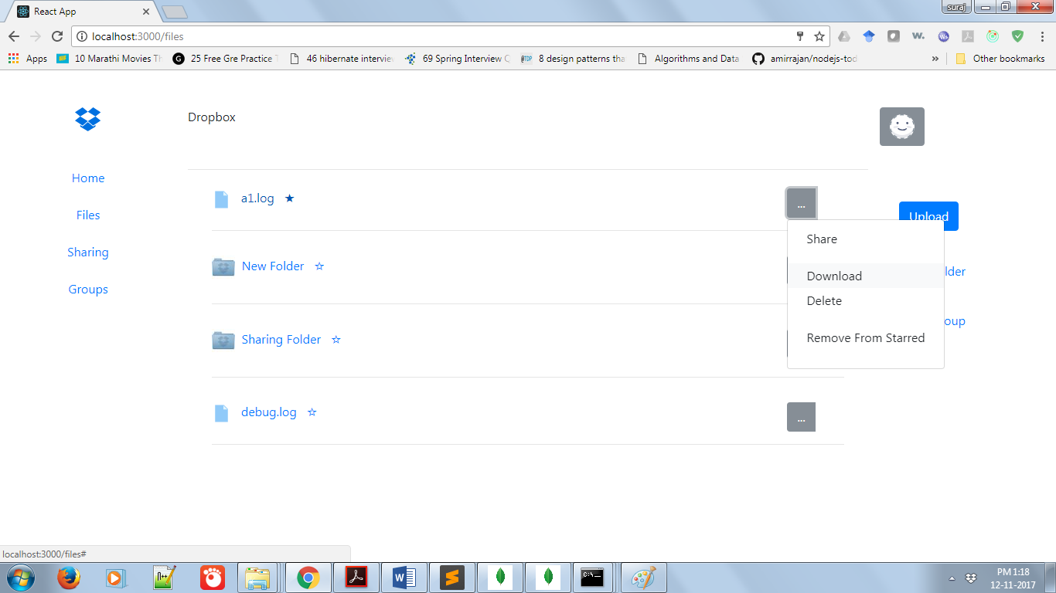

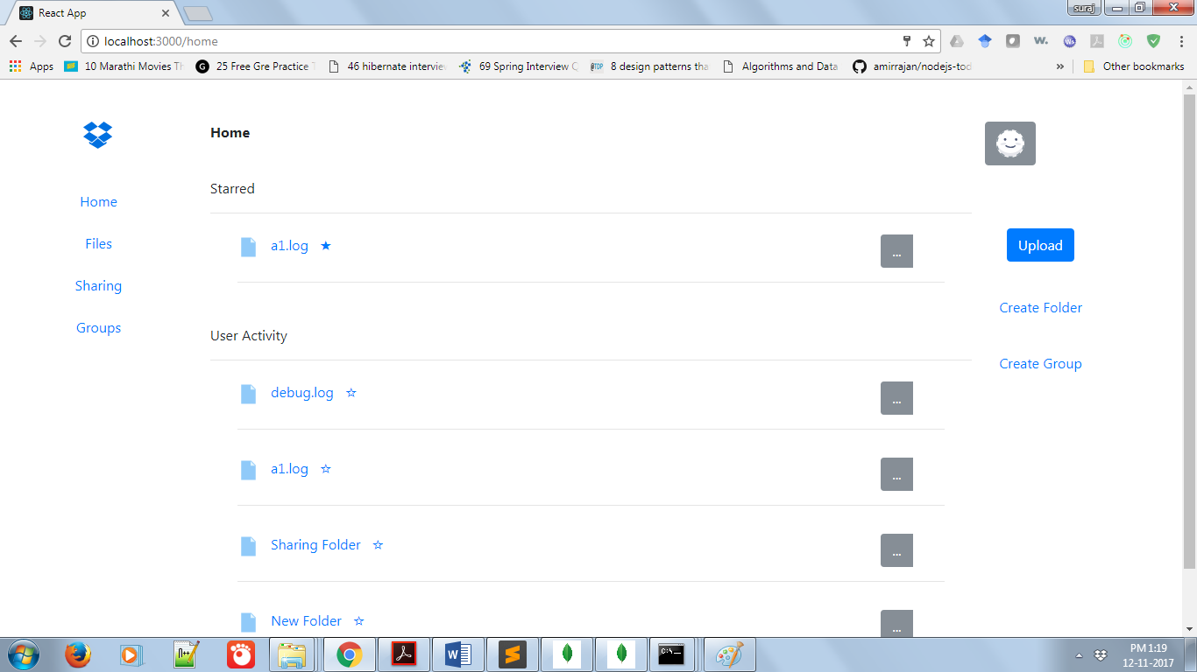

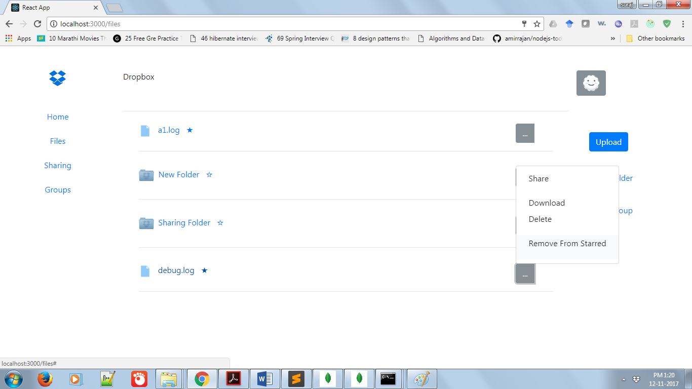

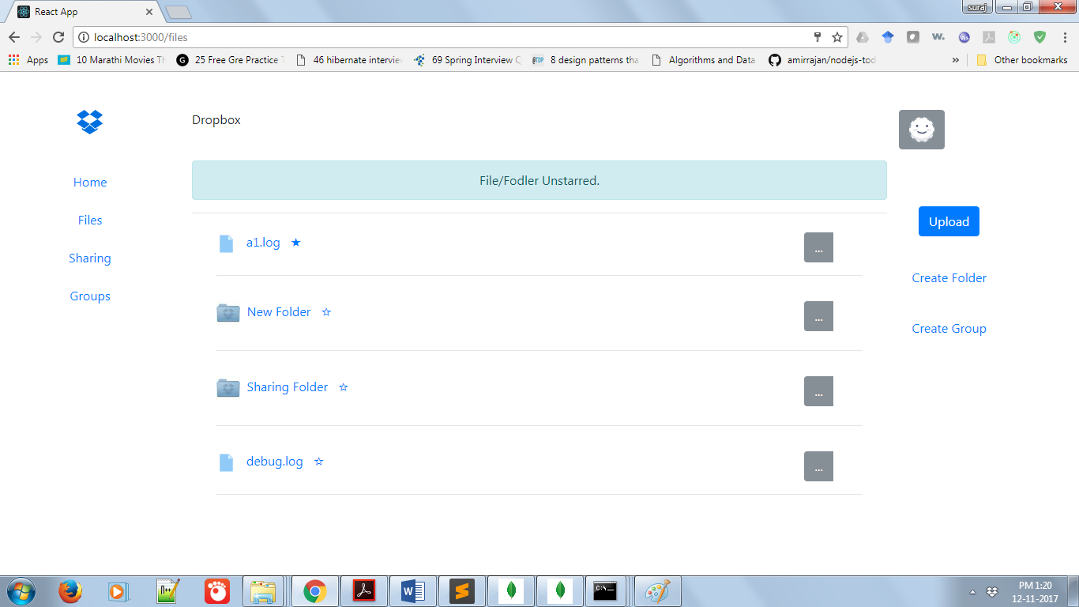

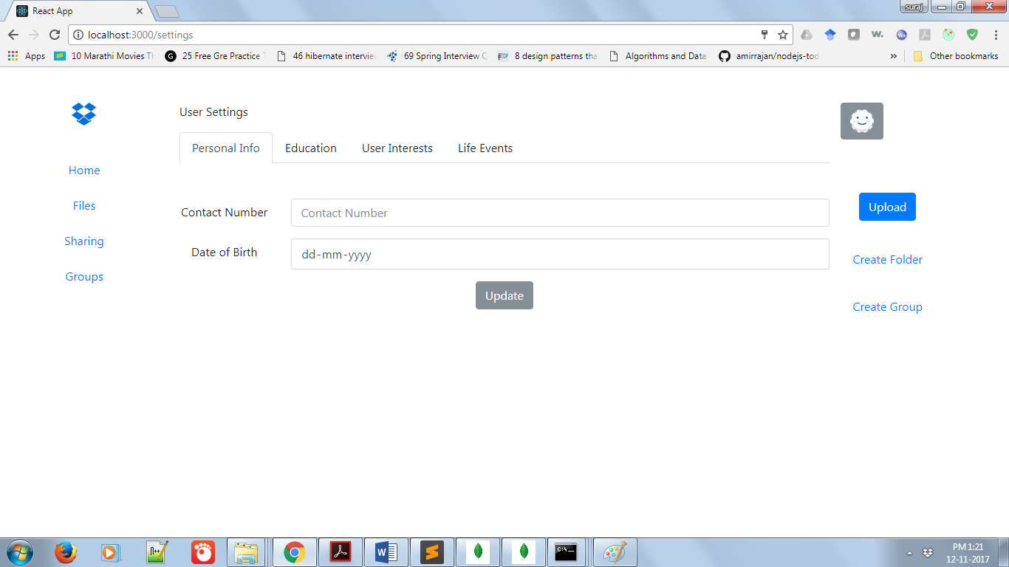

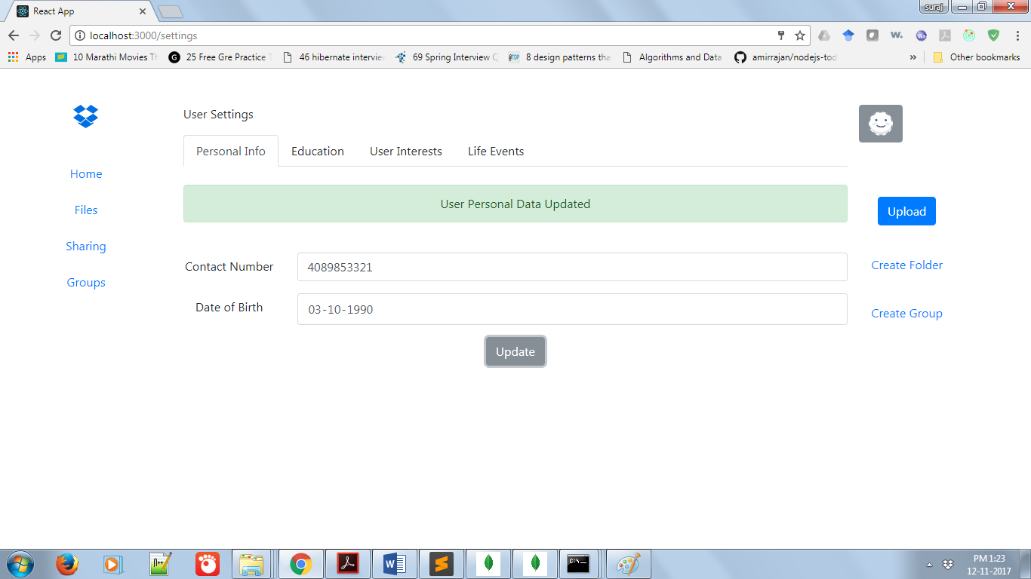

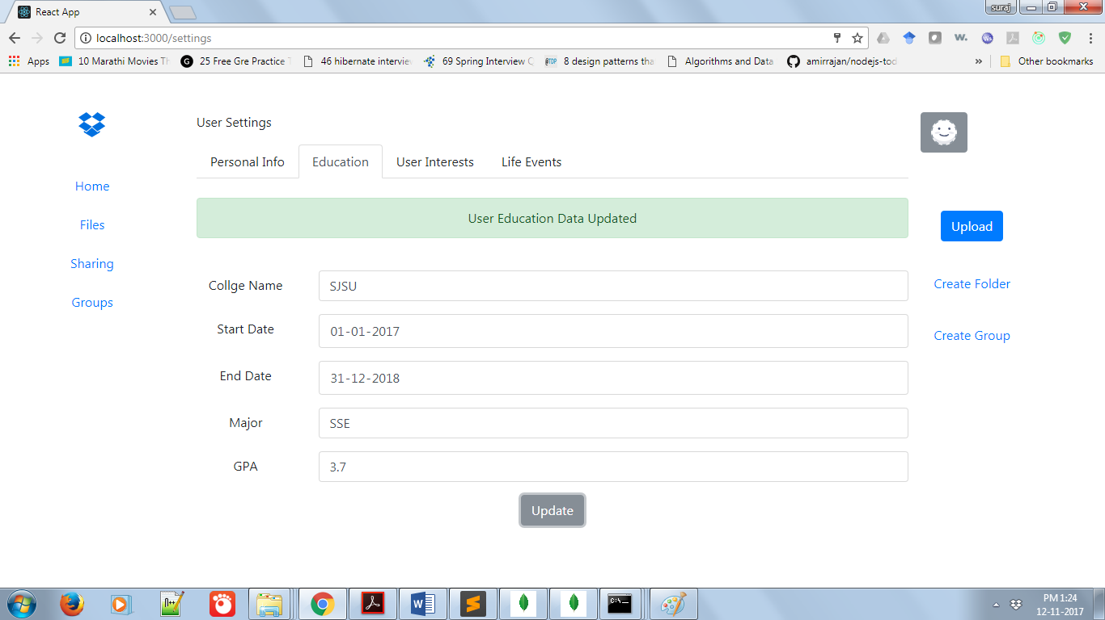

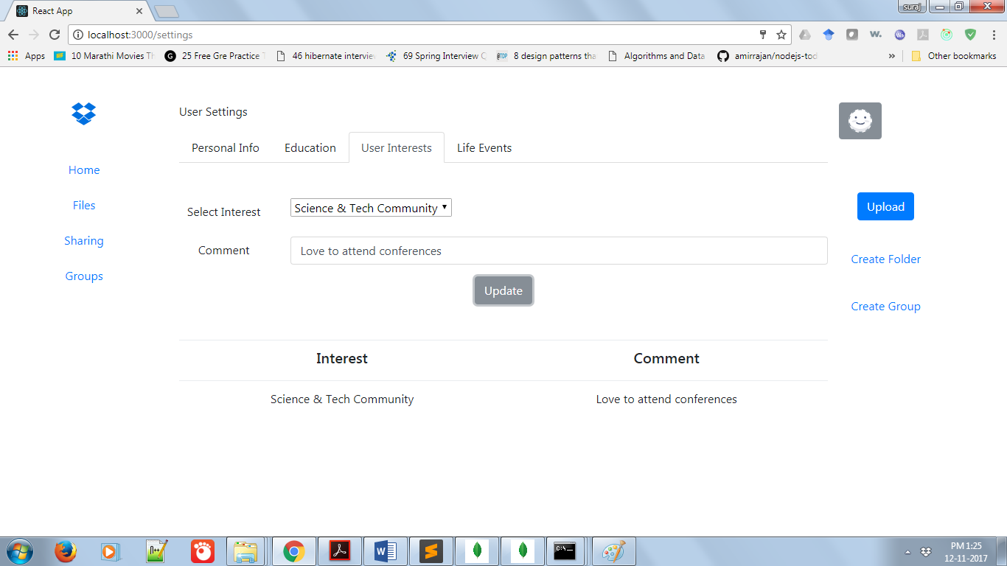

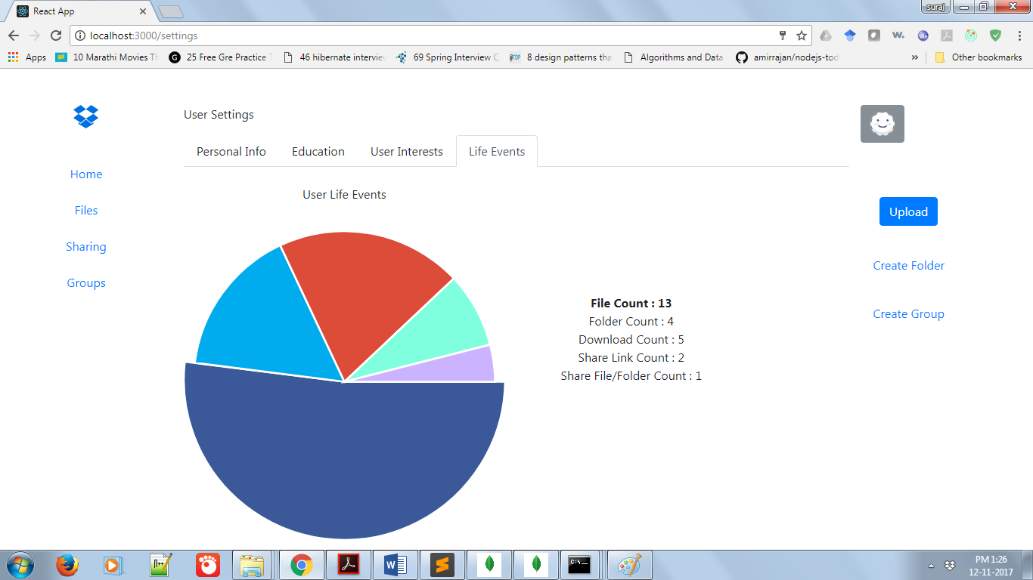

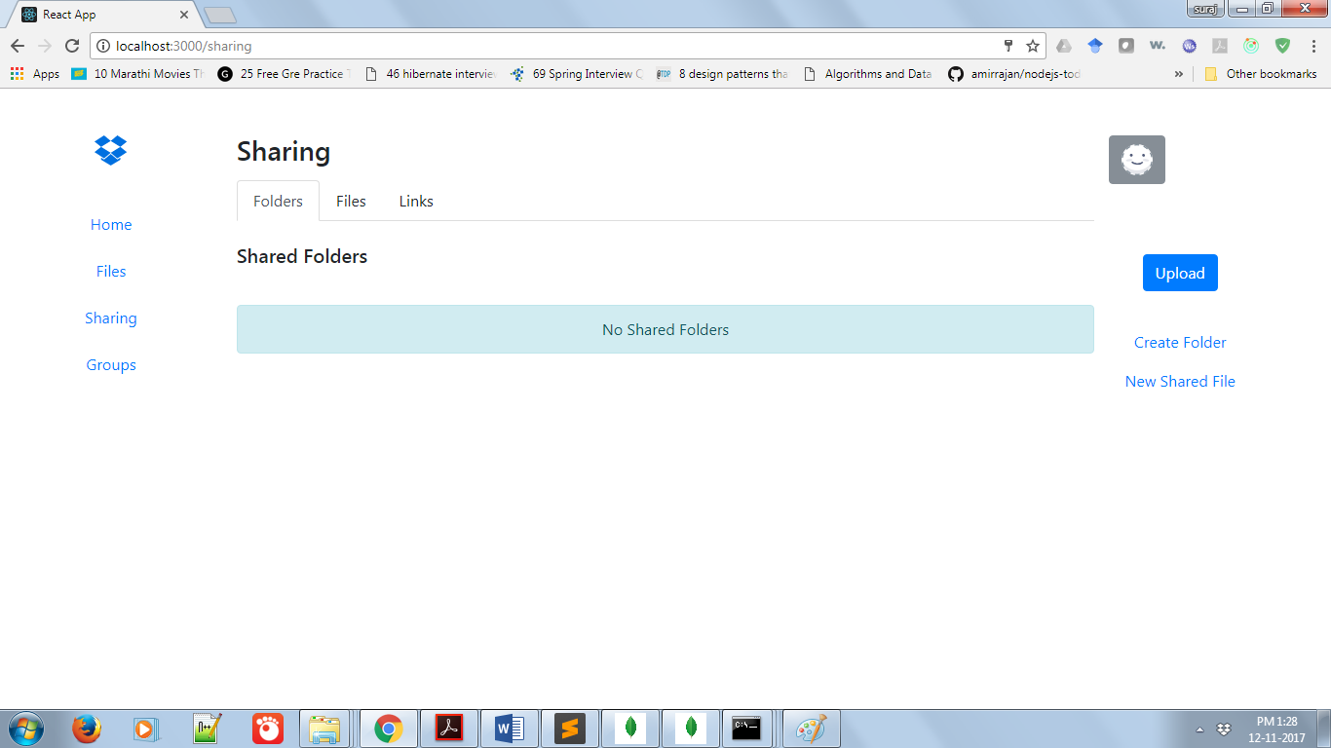

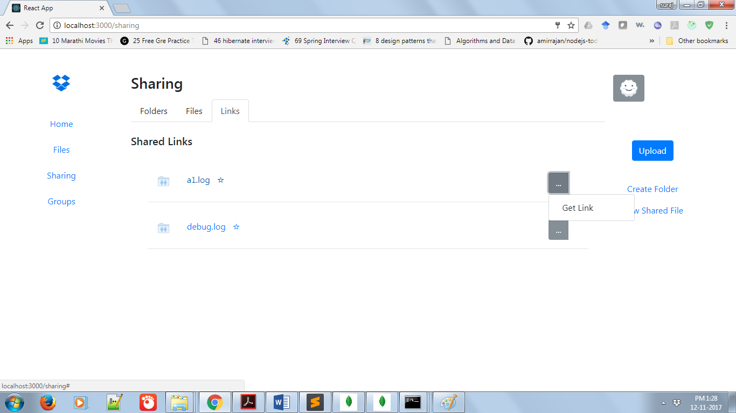

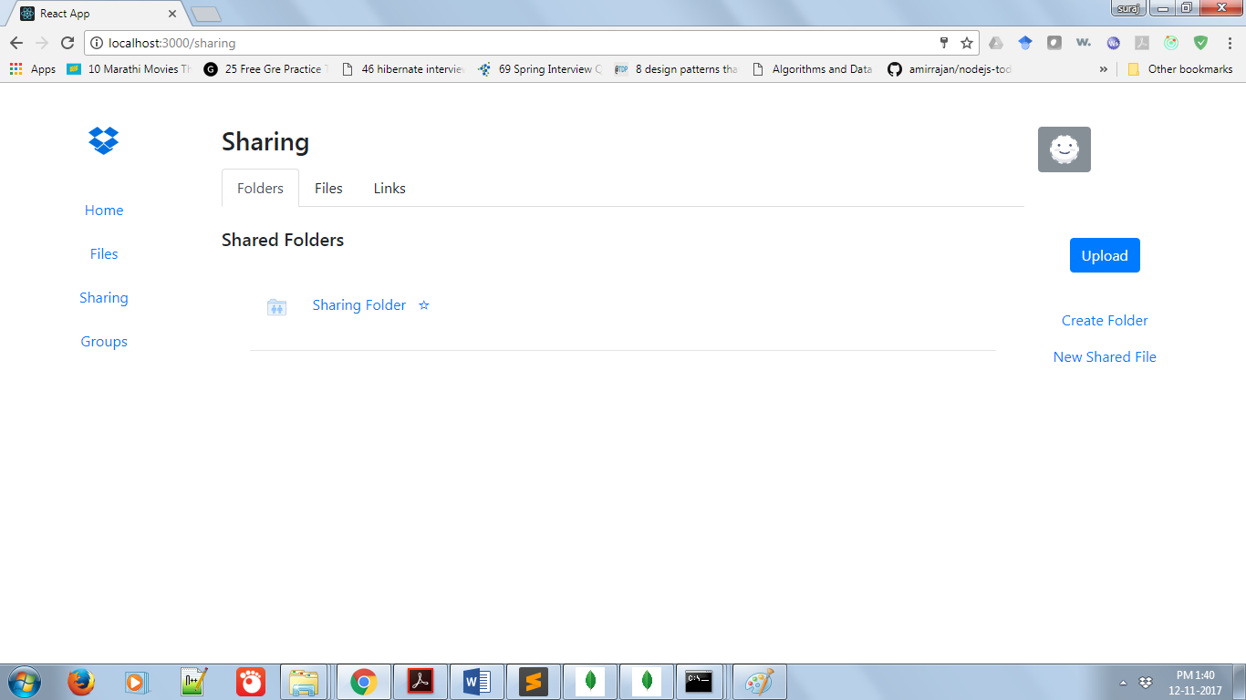

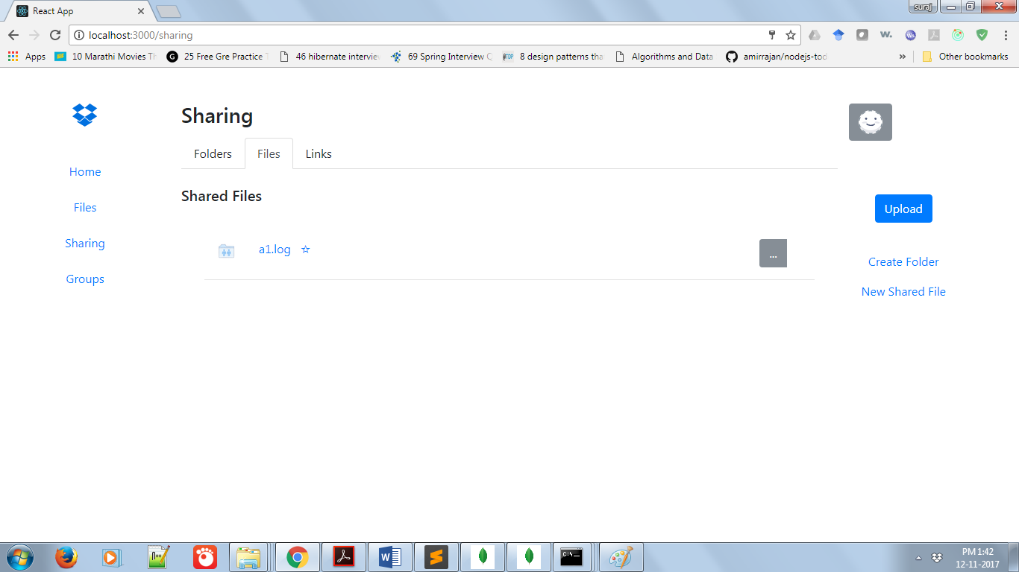

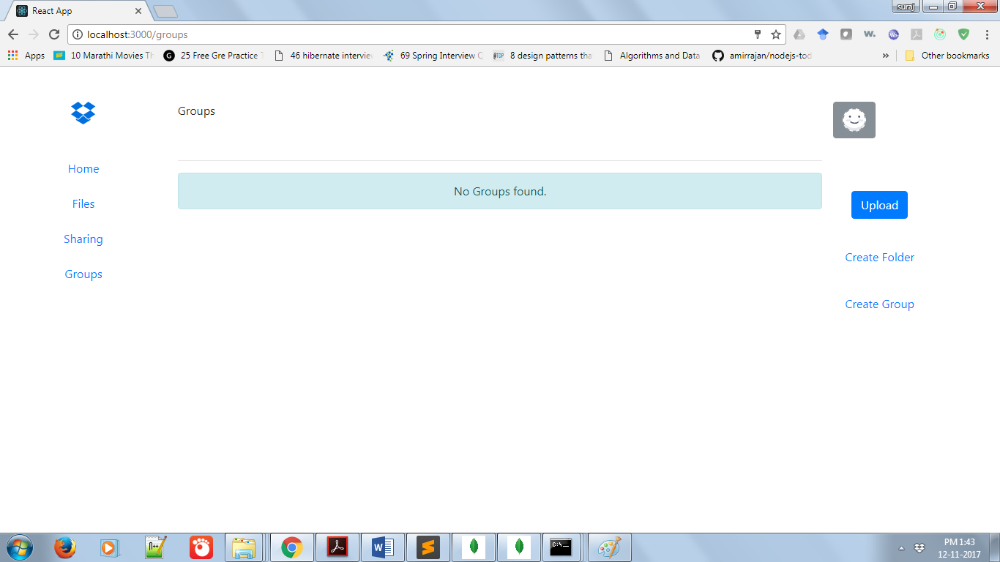

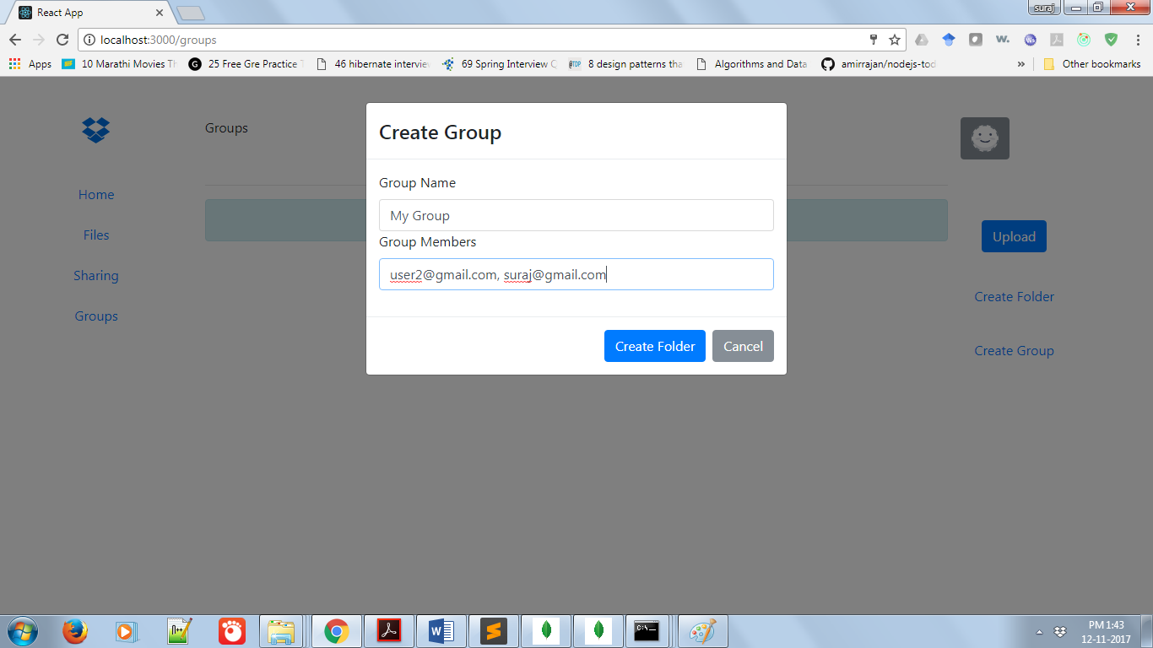

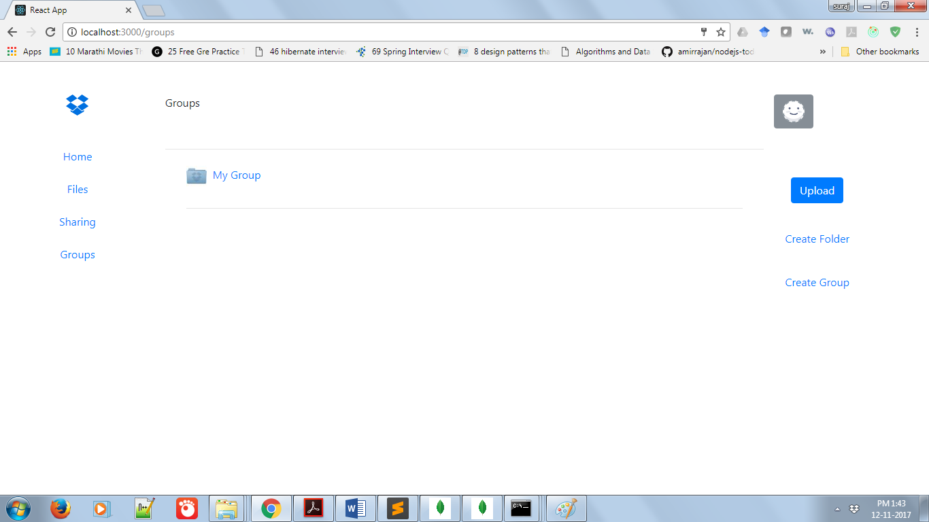

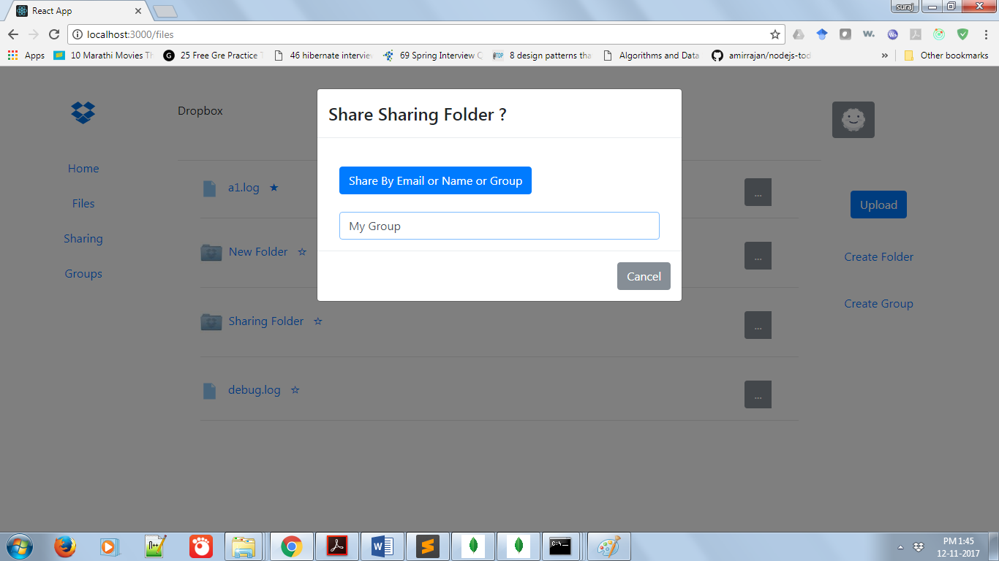

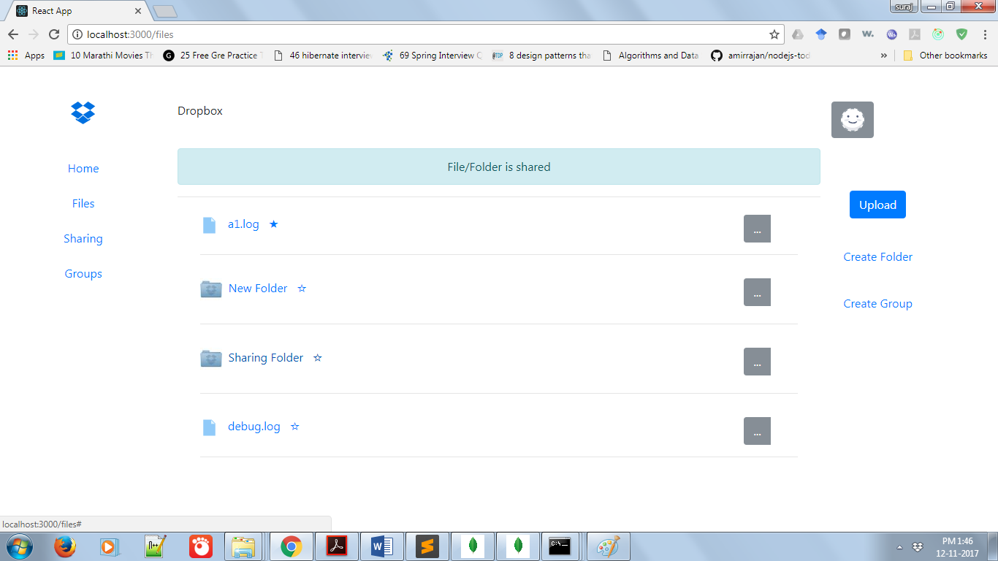

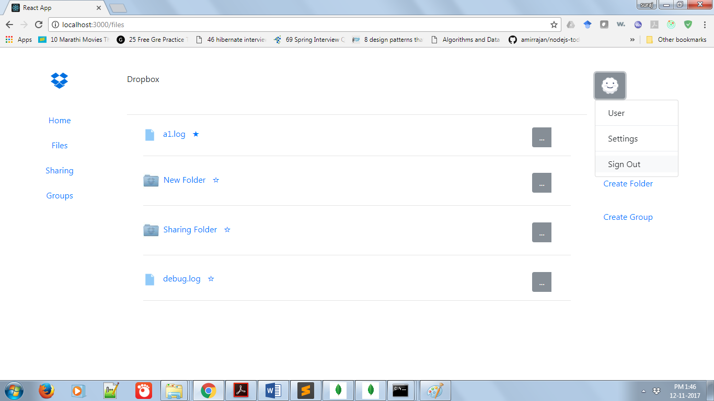

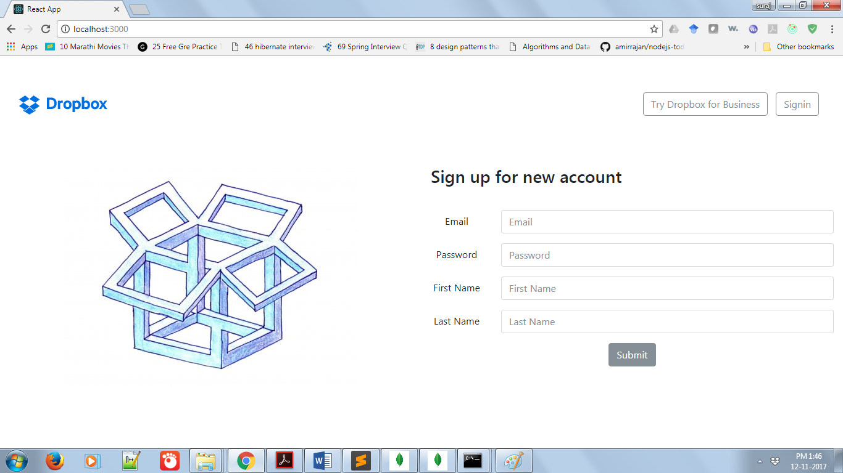

**Performance Measures:**

Dropbox server is been tested for evaluating performance for different number of concurrent users. Also, connection pooling is one of the parameters that is considered for load testing using Jmeter. Three different scenarios are considered for load testing. First is no connection pooling, connection pooling provided by database package and third is custom own implementation of connection pooling. Below are screenshots of performances of several APIs.

**No Connection Pooling:**

1. **User signup**
2. **100 Concurrent Users**

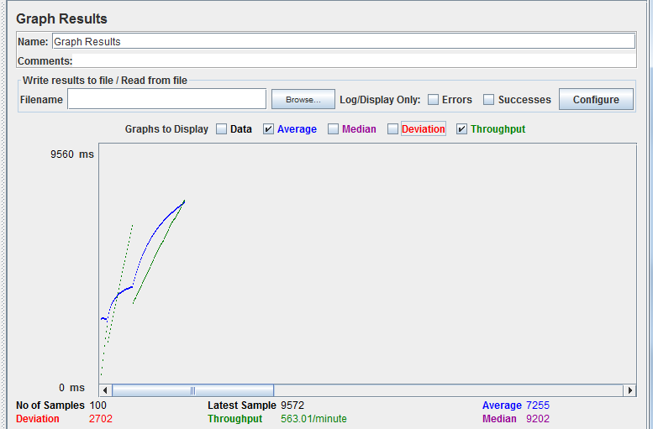

1. **200 Concurrent Users**

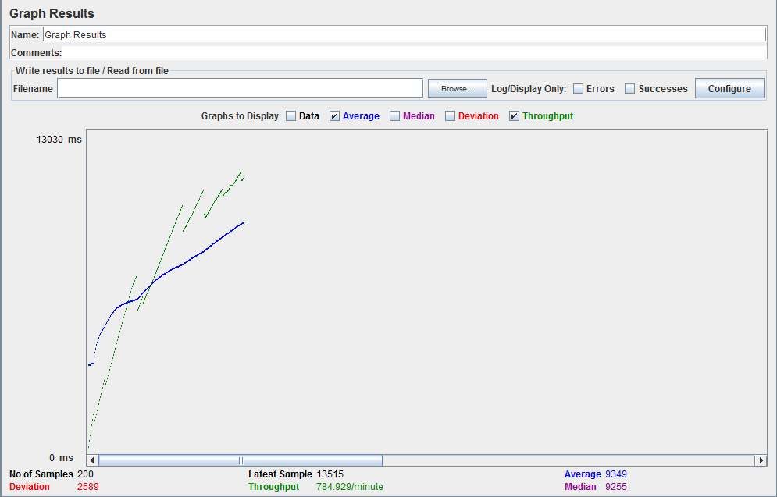

1. **300 Concurrent Users**

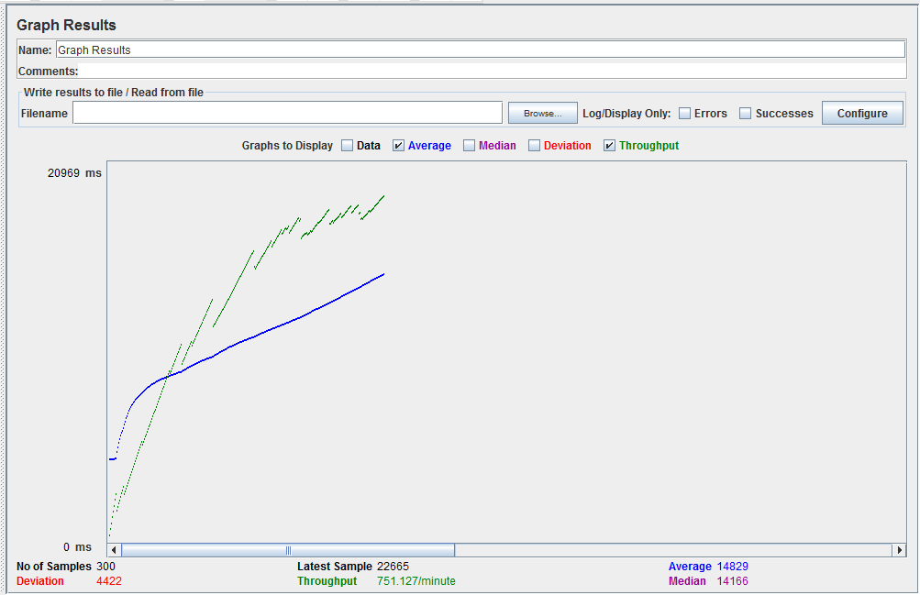

1. **400 Concurrent Users**

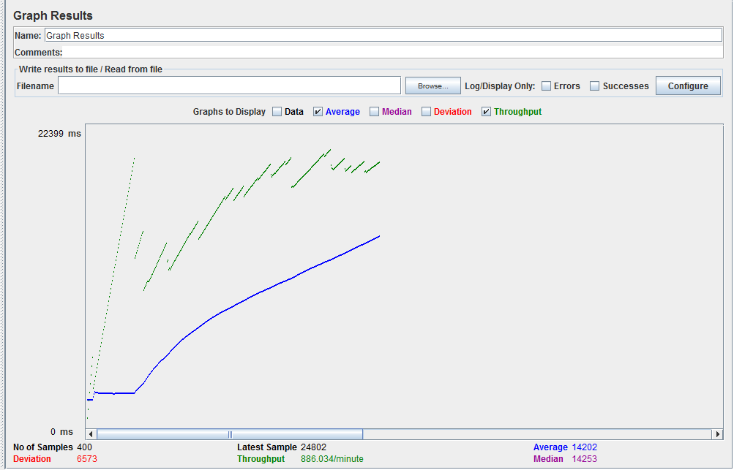

1. **500 Concurrent Users**

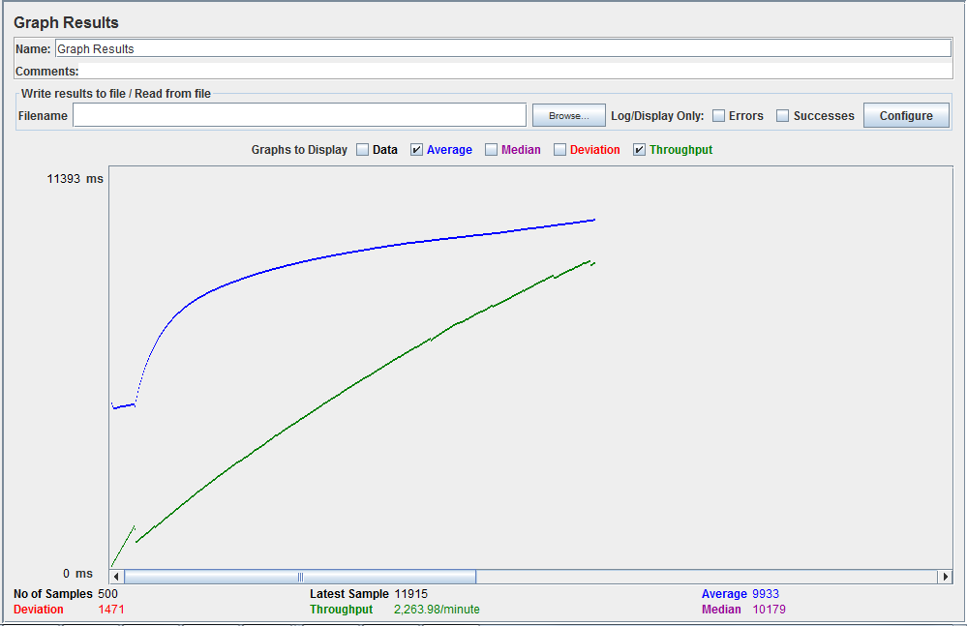

1. **Create a new folder**
   1. **100 Concurrent Users**

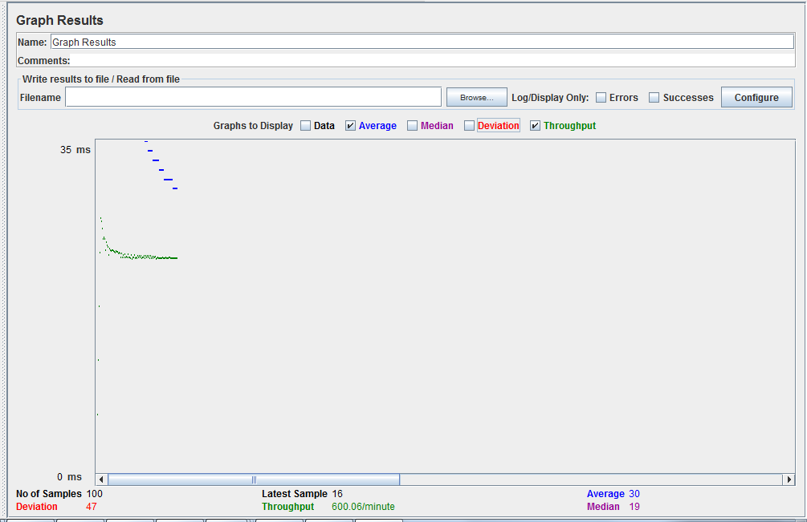

* 1. **200 Concurrent Users**

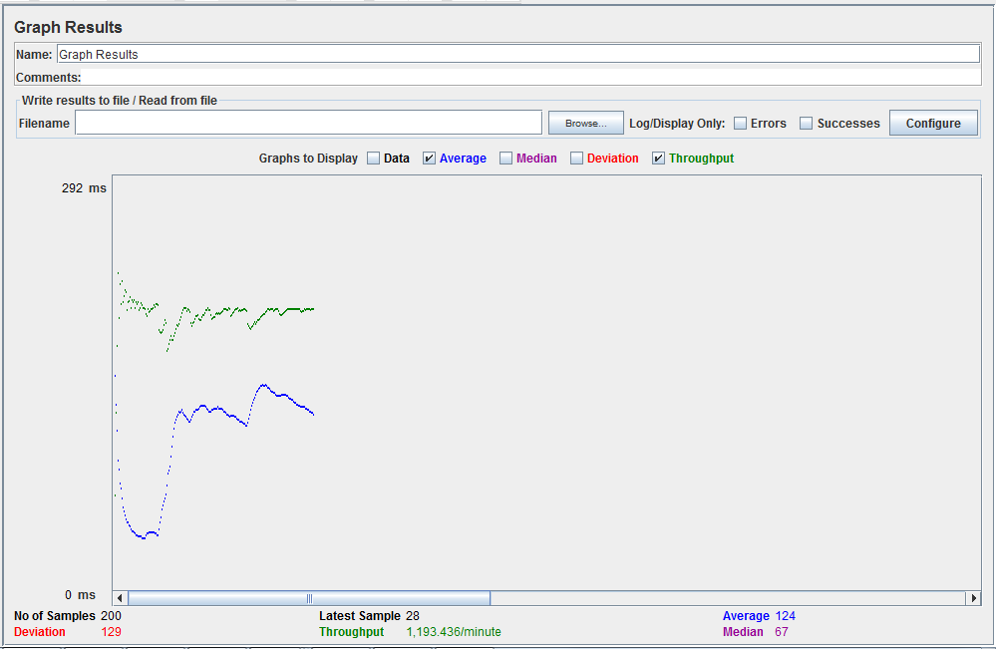

* 1. **300 Concurrent Users**

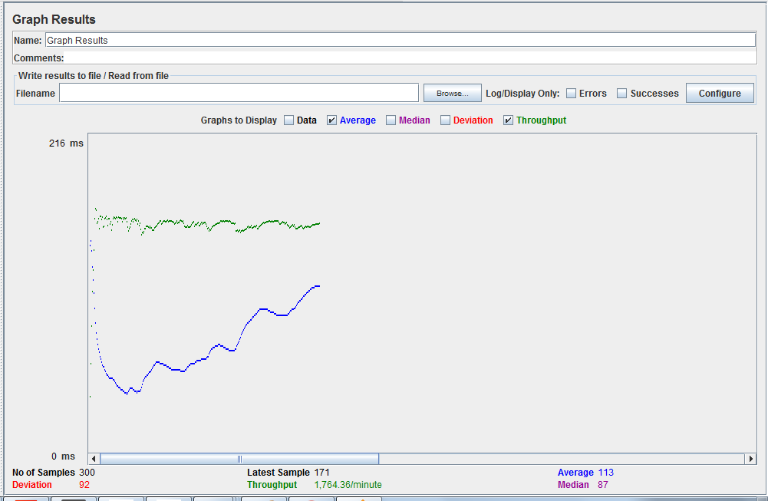

* 1. **400 Concurrent Users**

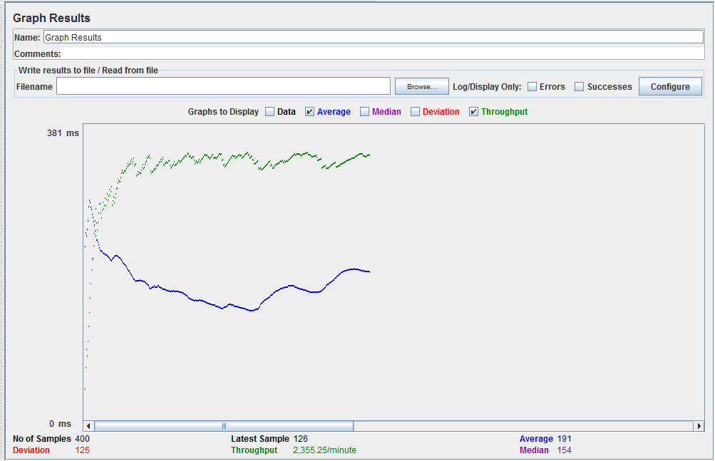

* 1. **500 Concurrent Users**

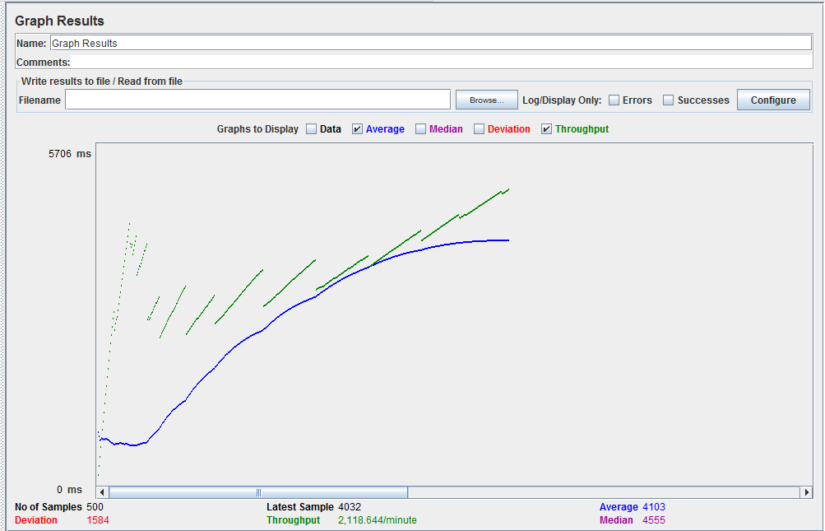

1. **Get all files and folders of a user**
   1. **100 Concurrent Users**

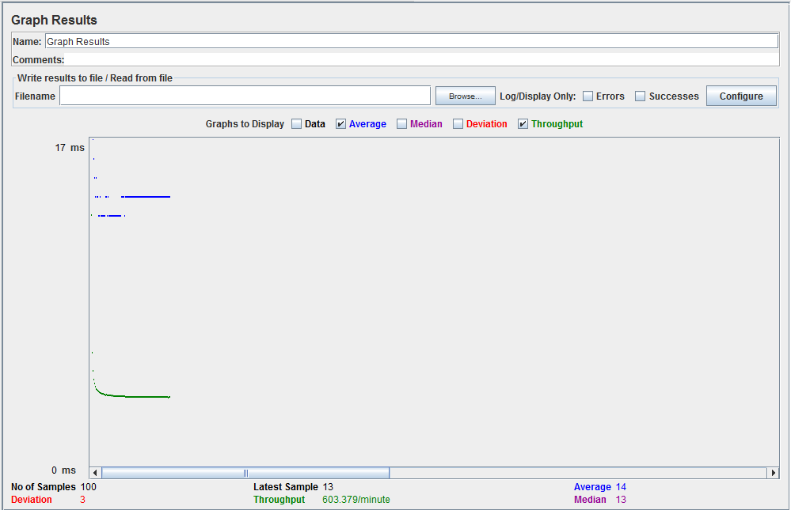

* 1. **200 Concurrent Users**

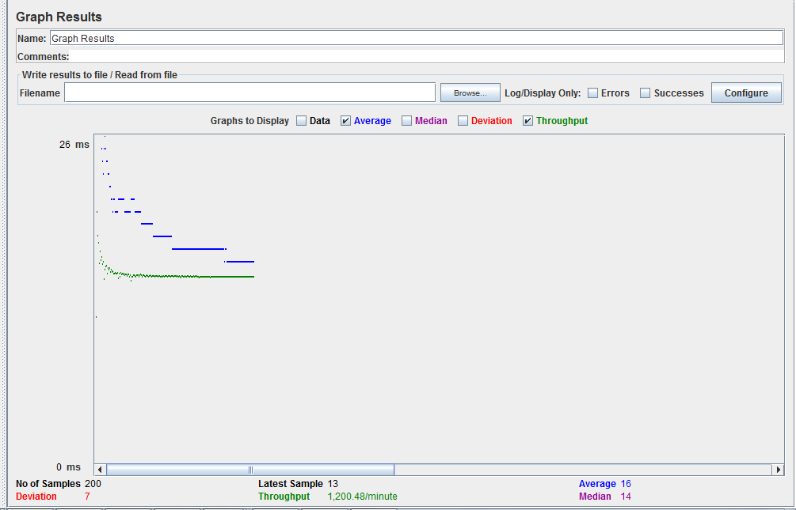

* 1. **300 Concurrent Users**

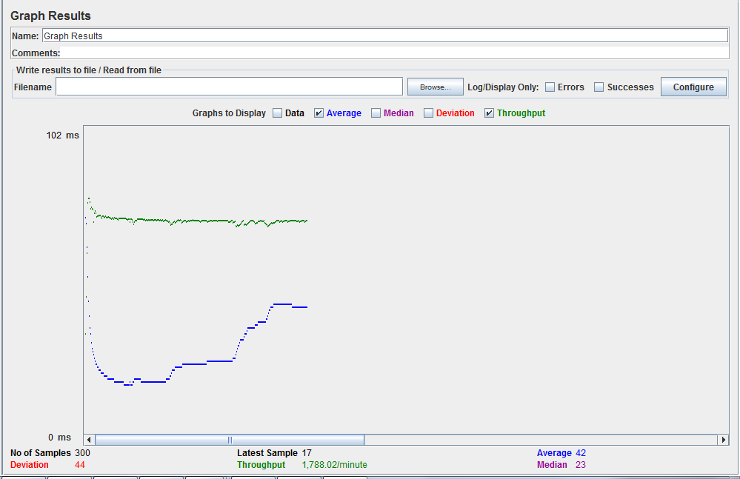

* 1. **400 Concurrent Users**

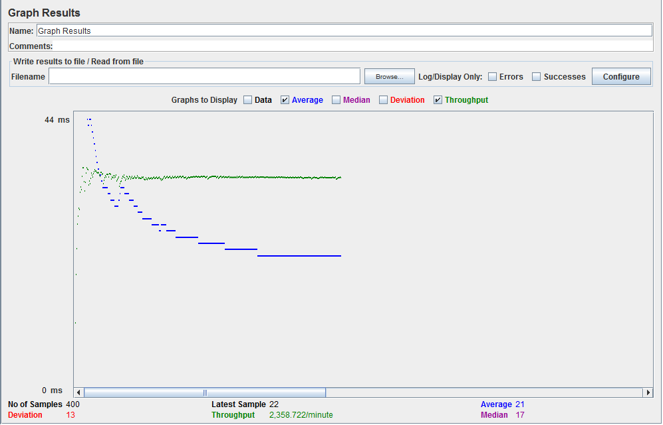

* 1. **500 Concurrent Users**

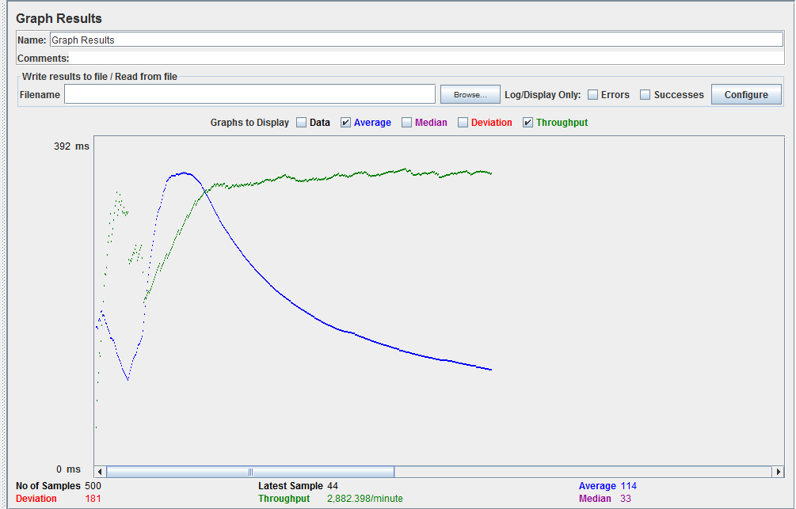

1. **Star a user file**
   1. **100 Concurrent Users**

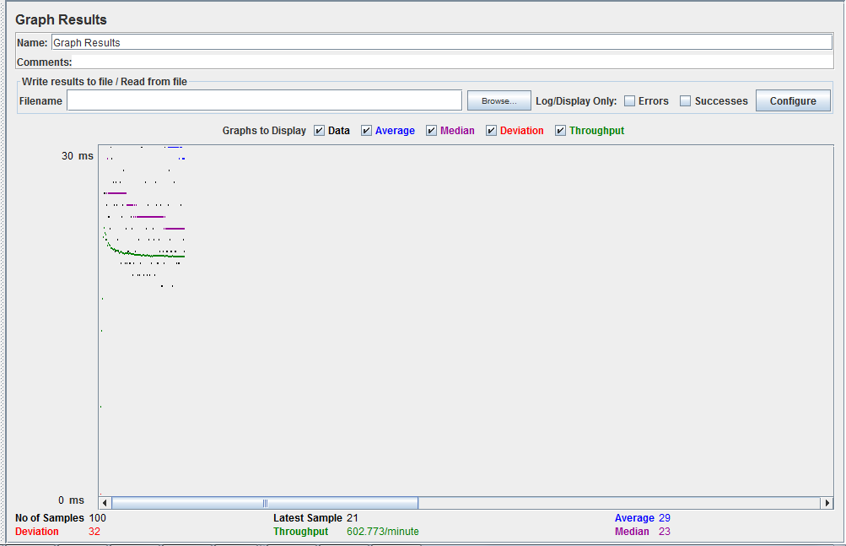

* 1. **200 Concurrent Users**

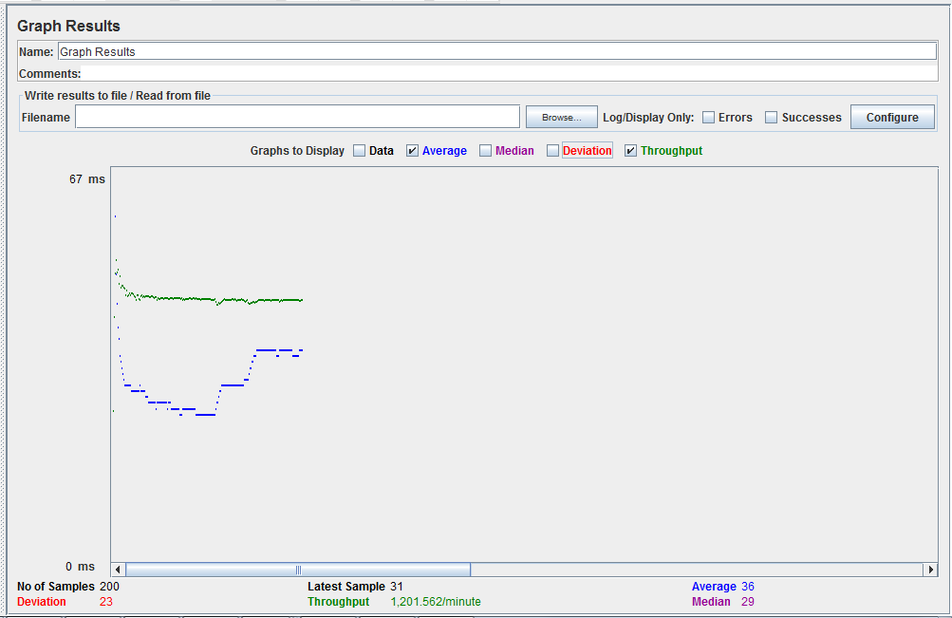

* 1. **300 Concurrent Users**

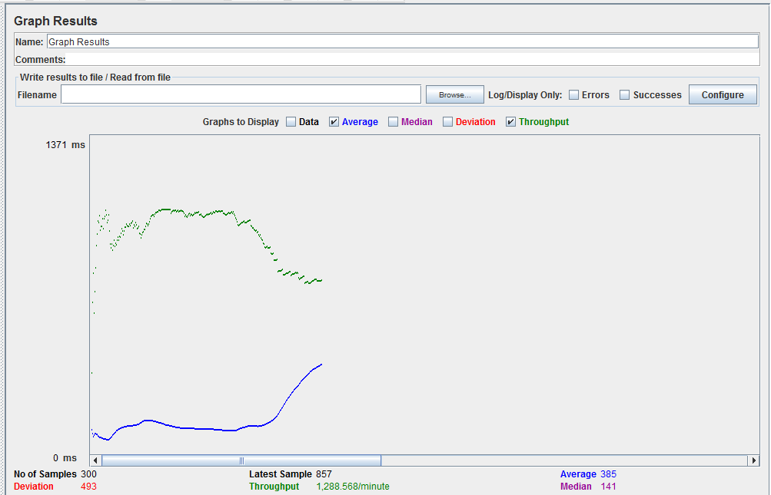

* 1. **400 Concurrent Users**

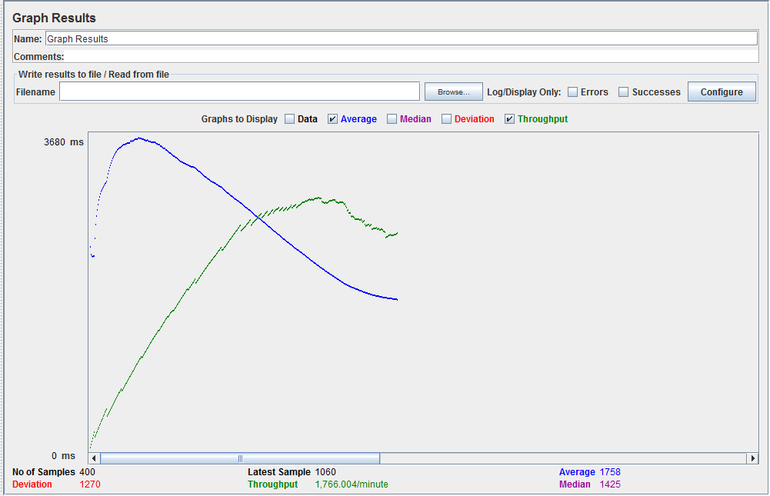

* 1. **500 Concurrent Users**

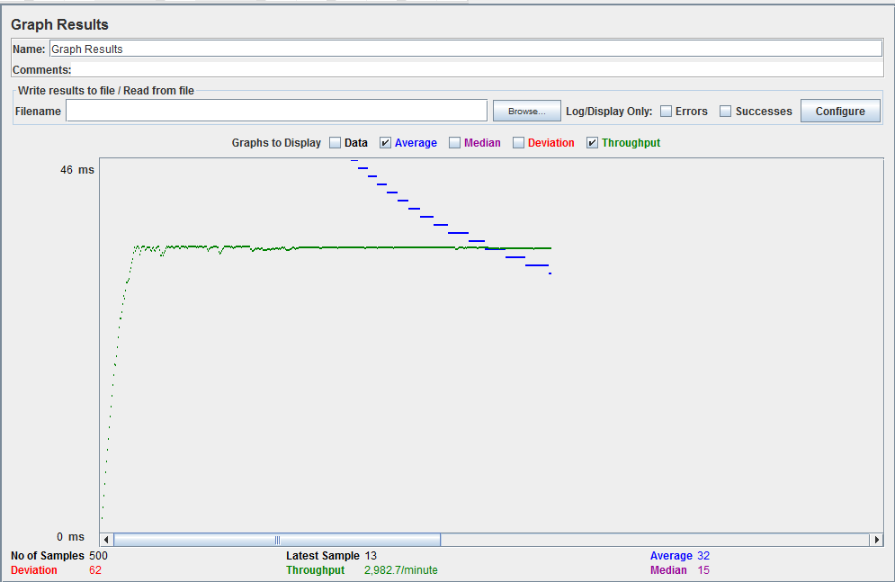

1. **Get all starred files**
   1. **100 Concurrent Users**

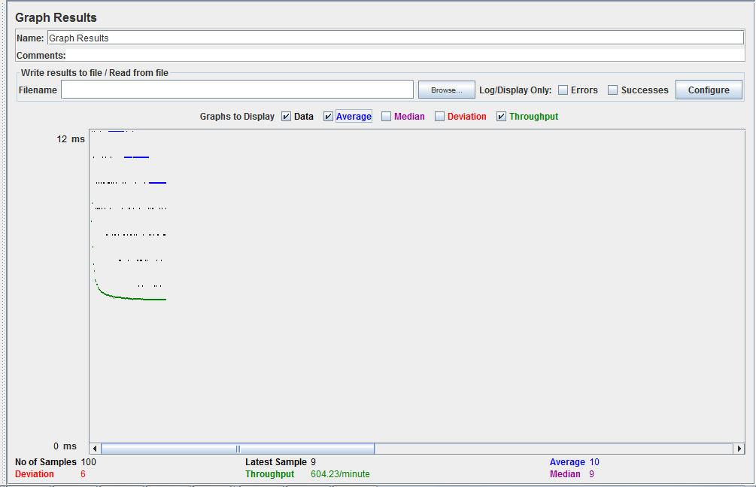

* 1. **200 Concurrent Users**

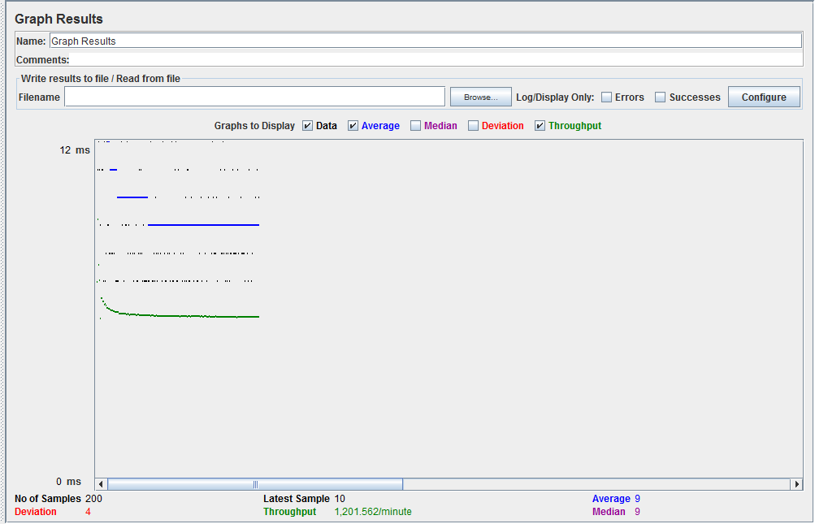

* 1. **300 Concurrent Users**

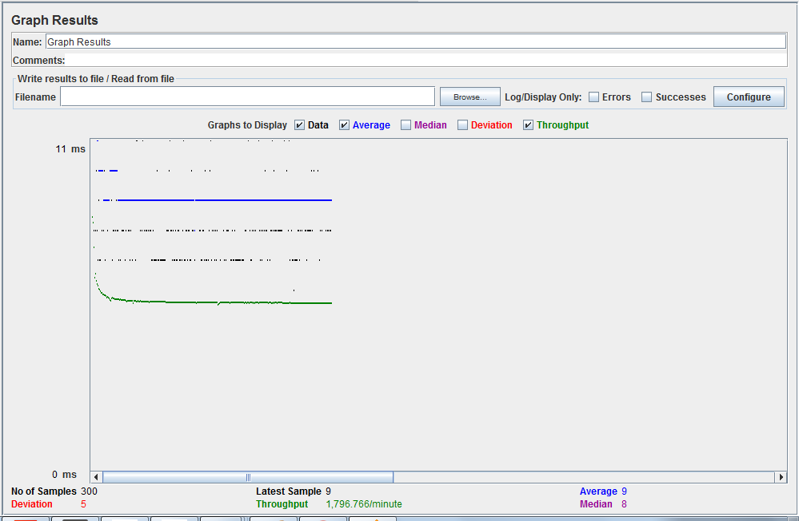

* 1. **400 Concurrent Users**

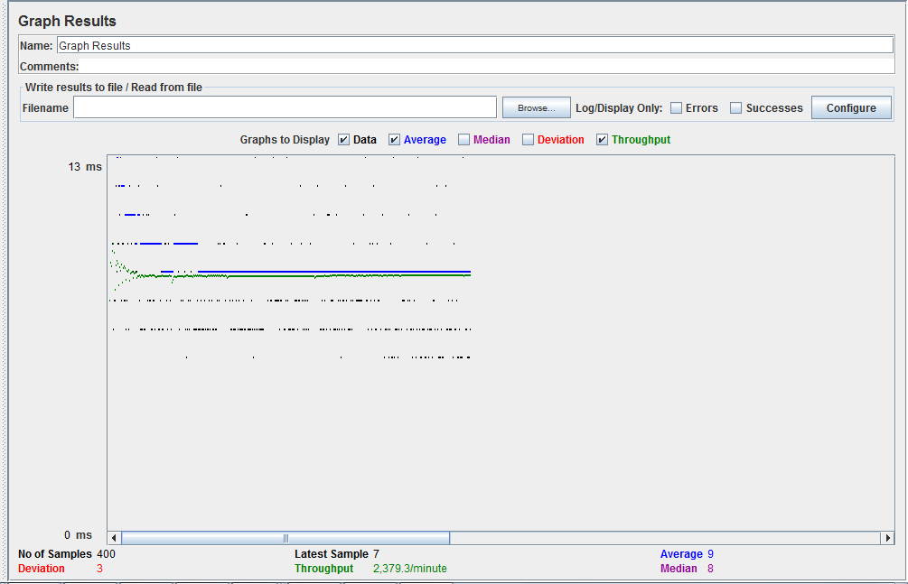

* 1. **500 Concurrent Users**

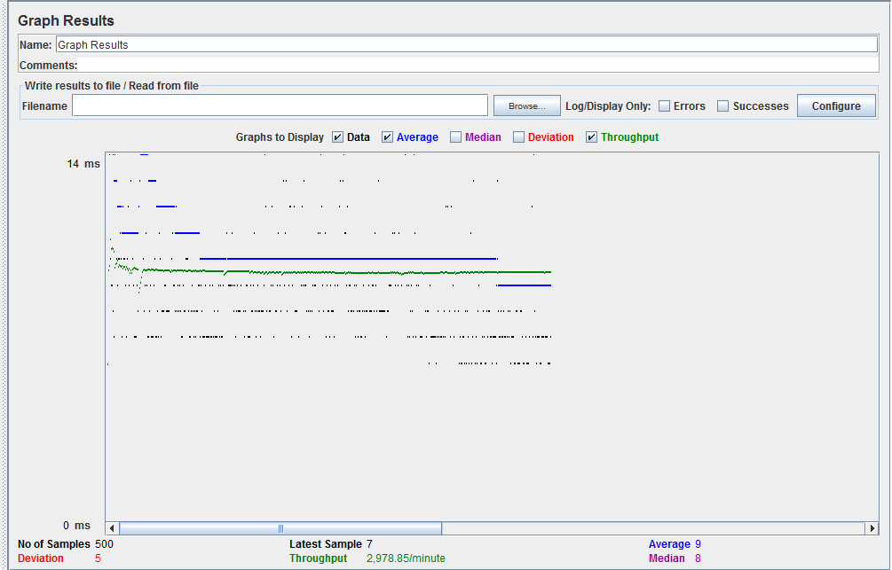

**DB provided Connection Pooling:**

1. **User signup**
2. **100 Concurrent Users**

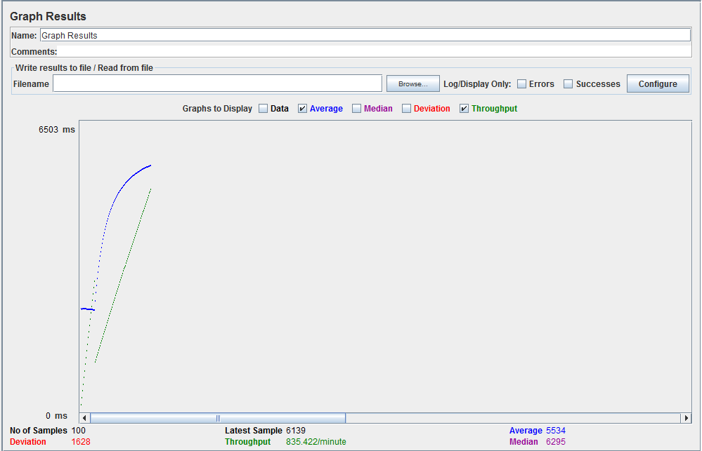

1. **200 Concurrent Users**

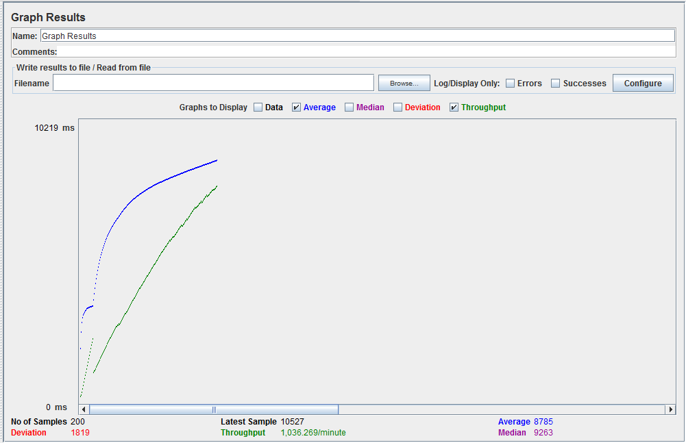

1. **300 Concurrent Users**

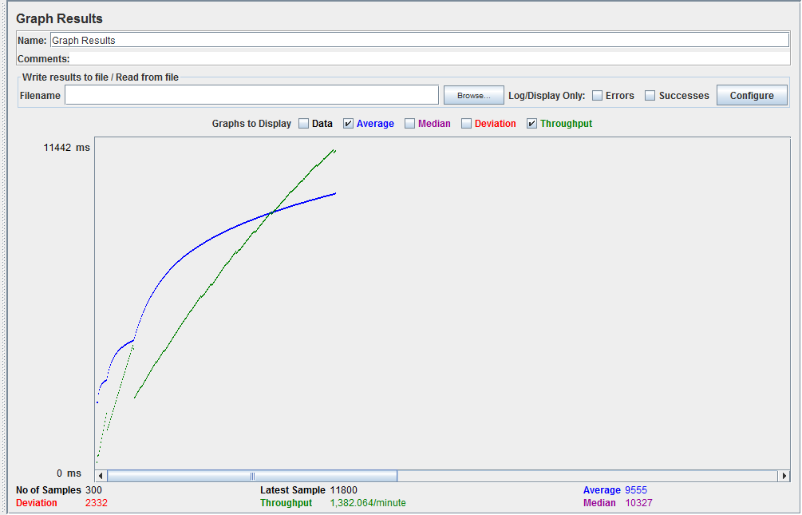

1. **400 Concurrent Users**



1. **500 Concurrent Users**

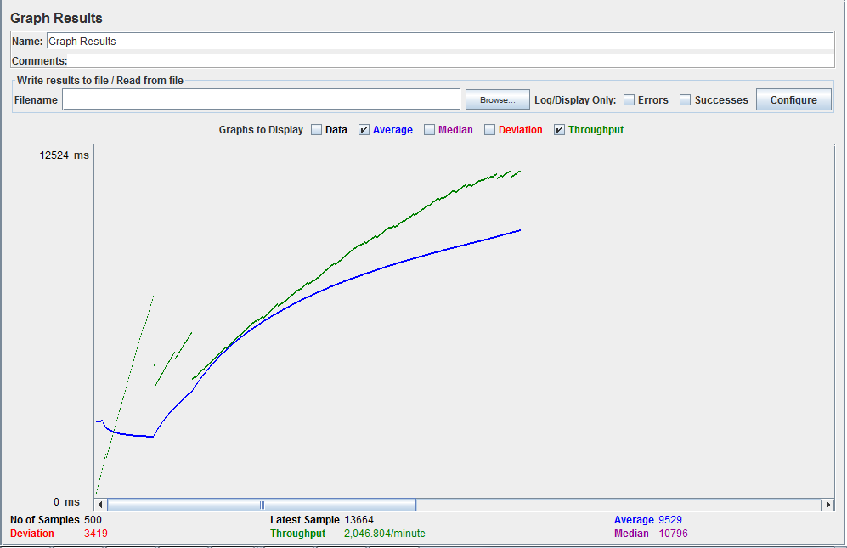

1. **Create a new folder**
   1. **100 Concurrent Users**

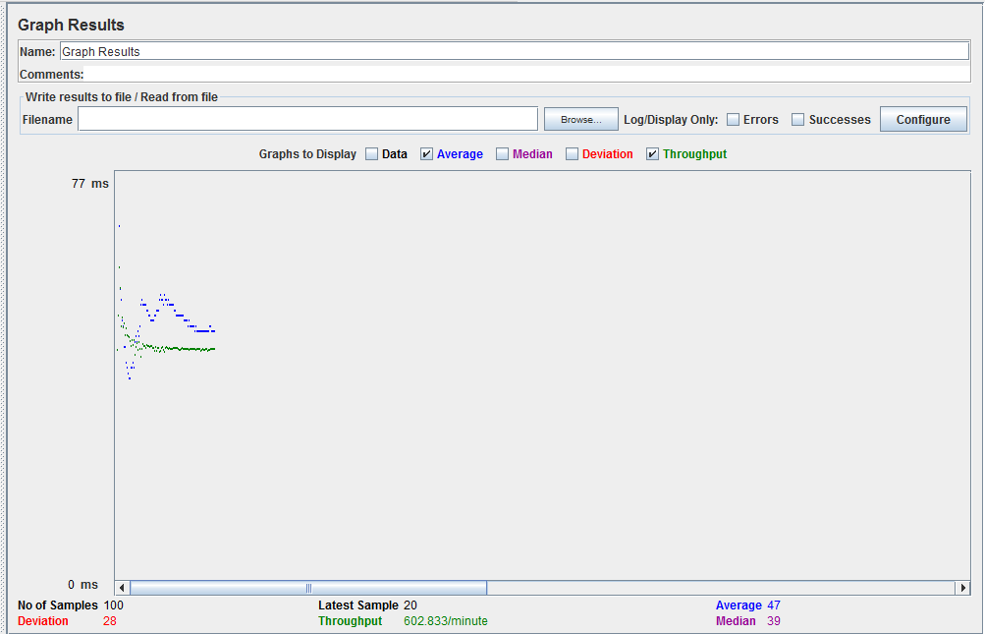

* 1. **200 Concurrent Users**

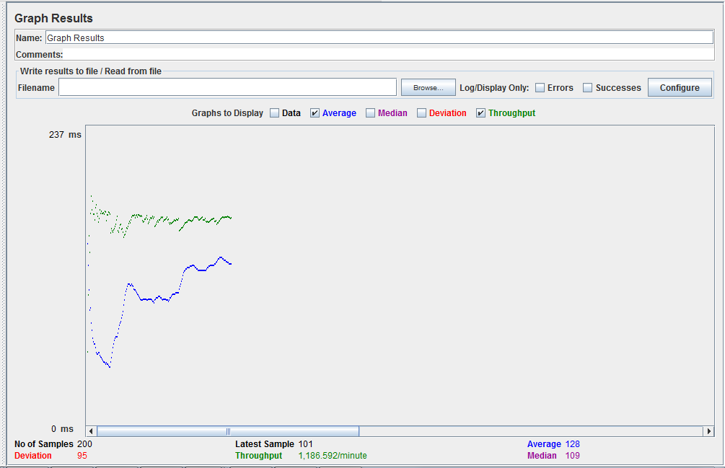

* 1. **300 Concurrent Users**

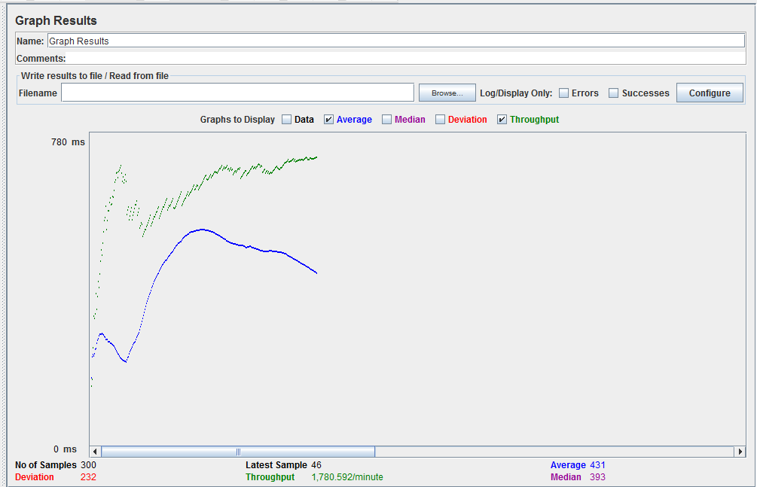

* 1. **400 Concurrent Users**

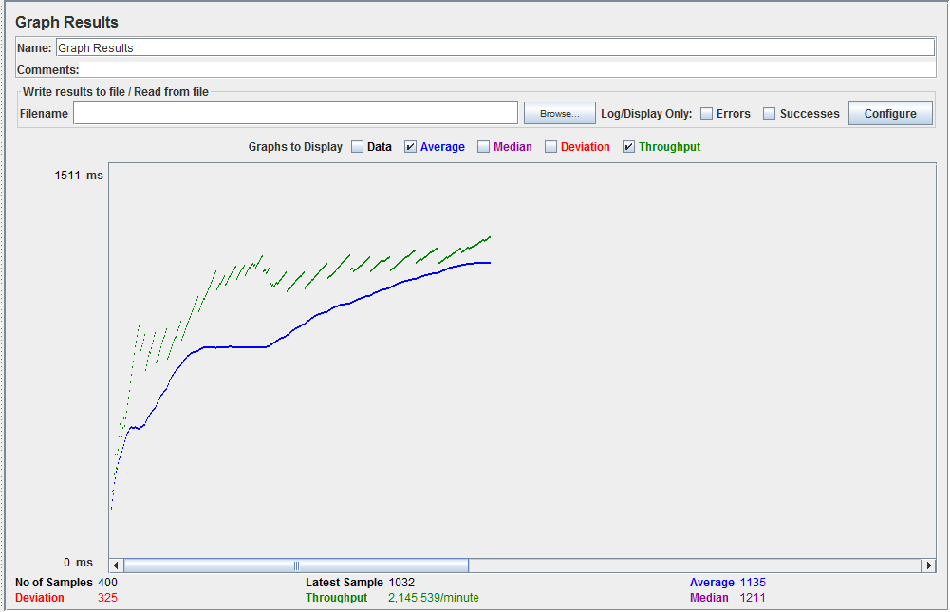

* 1. **500 Concurrent Users**

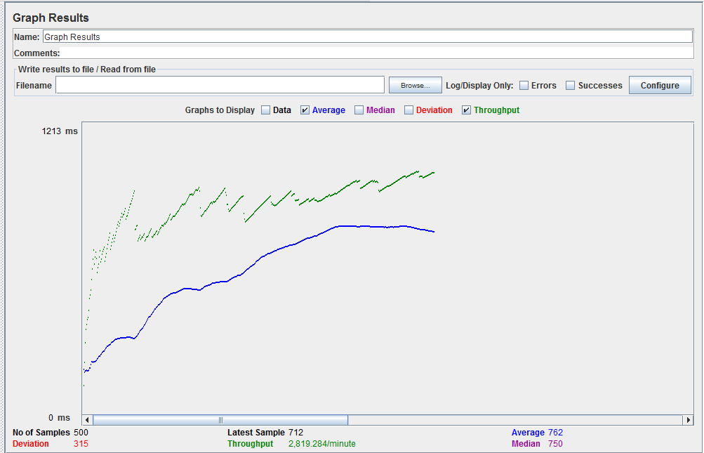

1. **Get all files and folders of a user**
   1. **100 Concurrent Users**

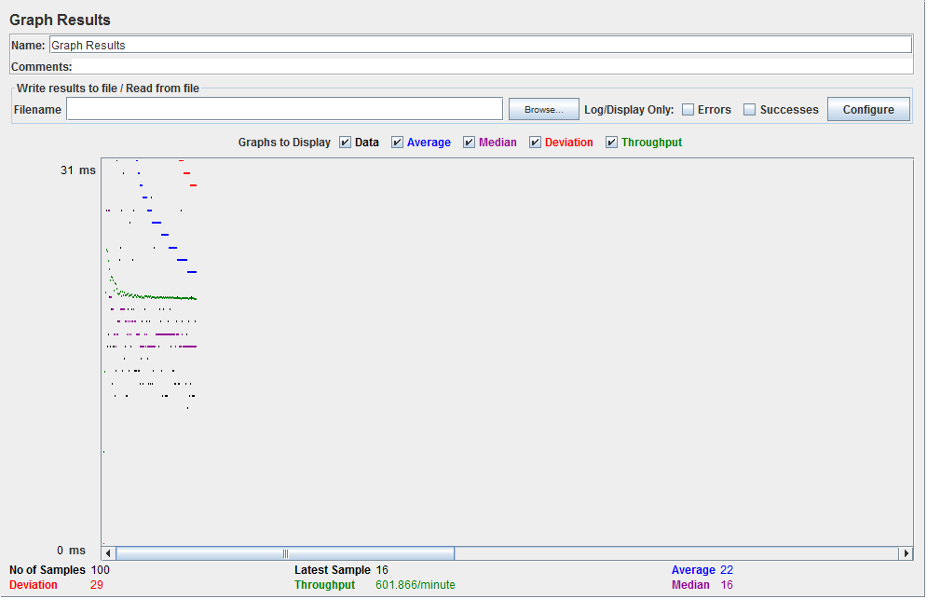

* 1. **200 Concurrent Users**

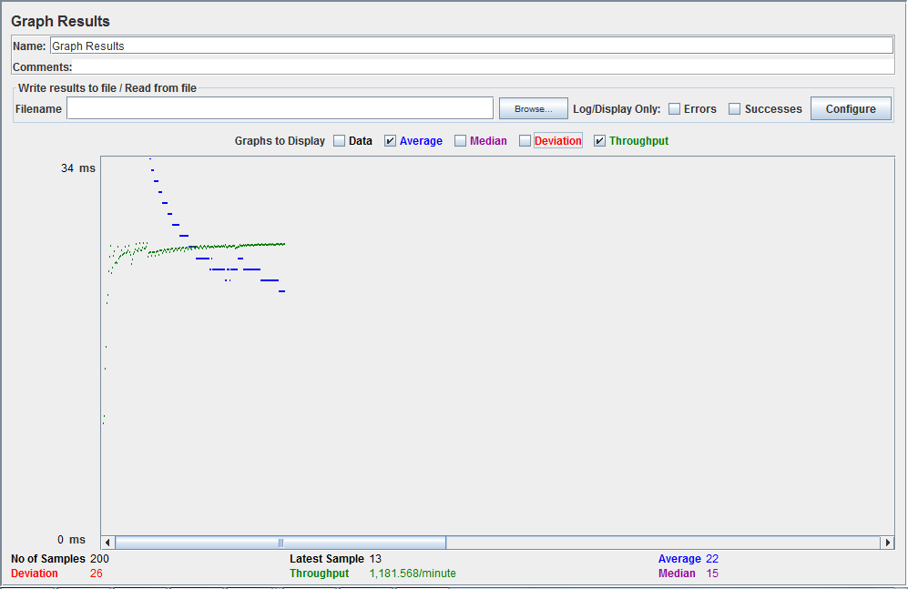

* 1. **300 Concurrent Users**

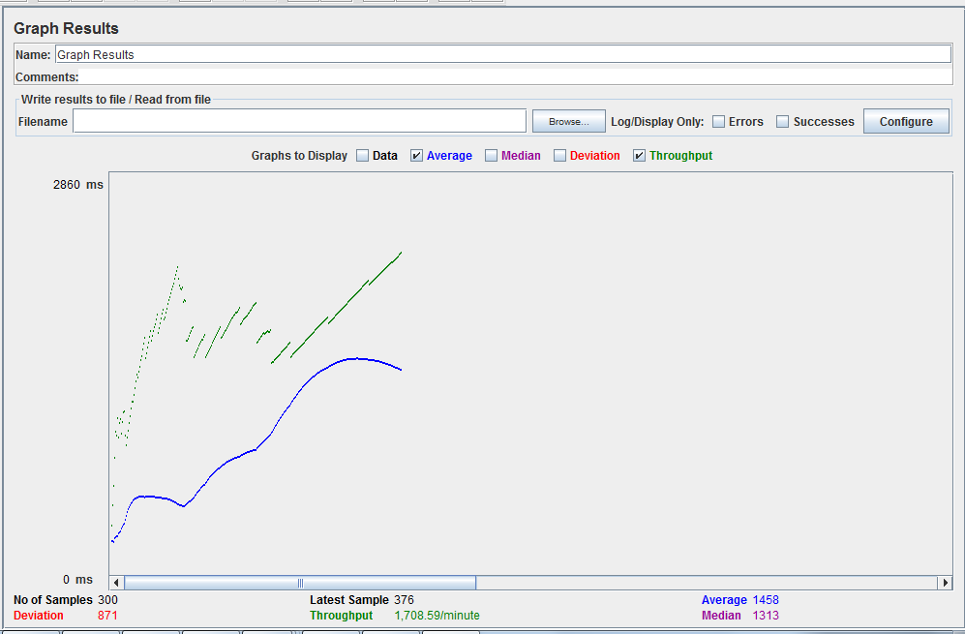

* 1. **400 Concurrent Users**

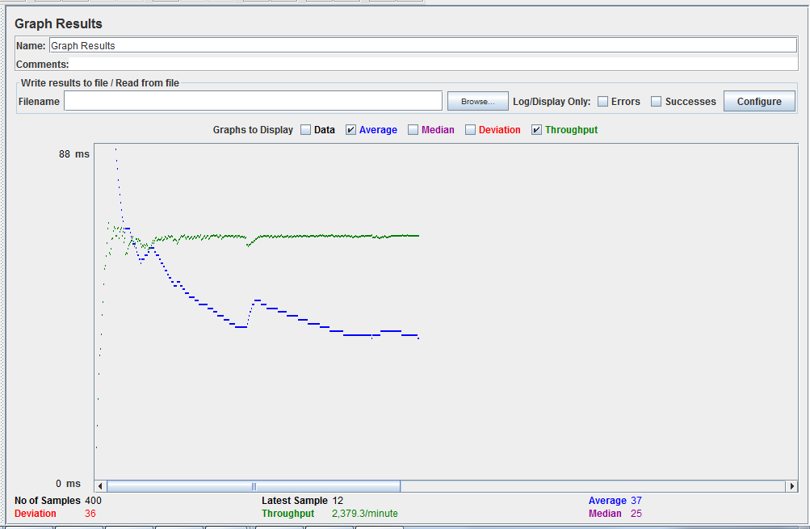

* 1. **500 Concurrent Users**

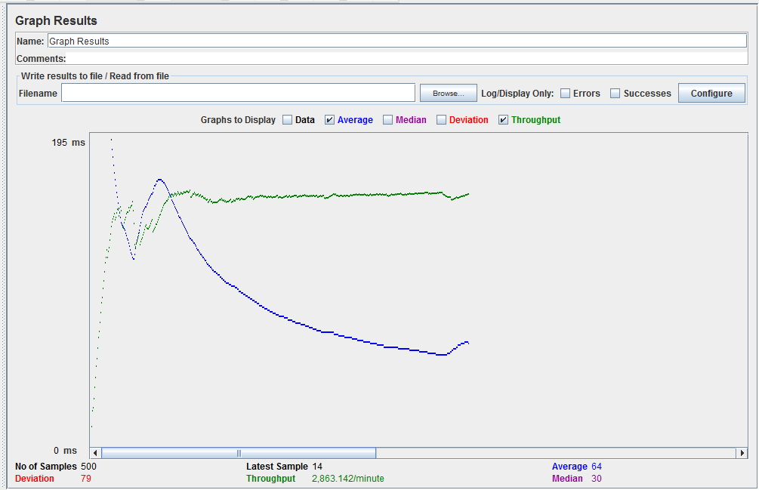

1. **Star a user file**
   1. **100 Concurrent Users**

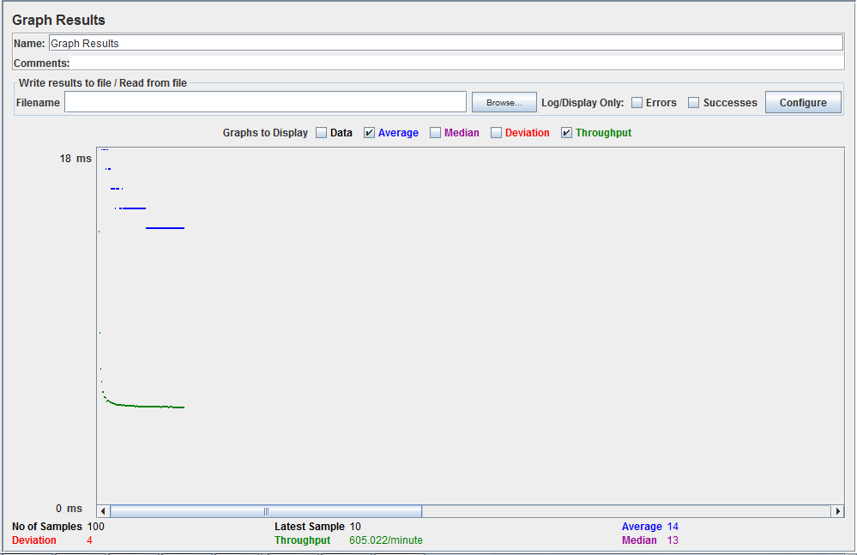

* 1. **200 Concurrent Users**

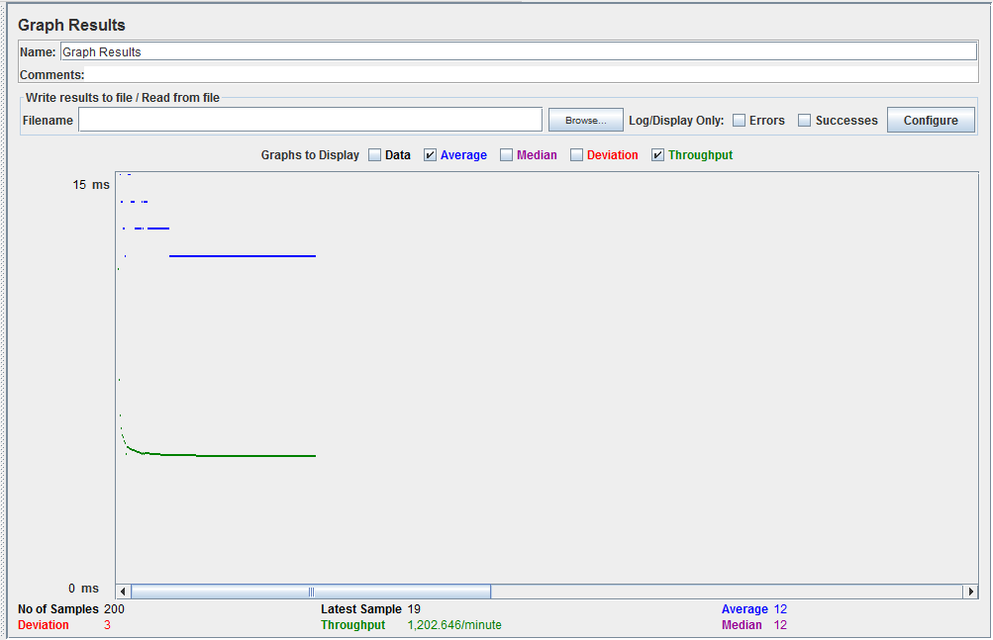

* 1. **300 Concurrent Users**

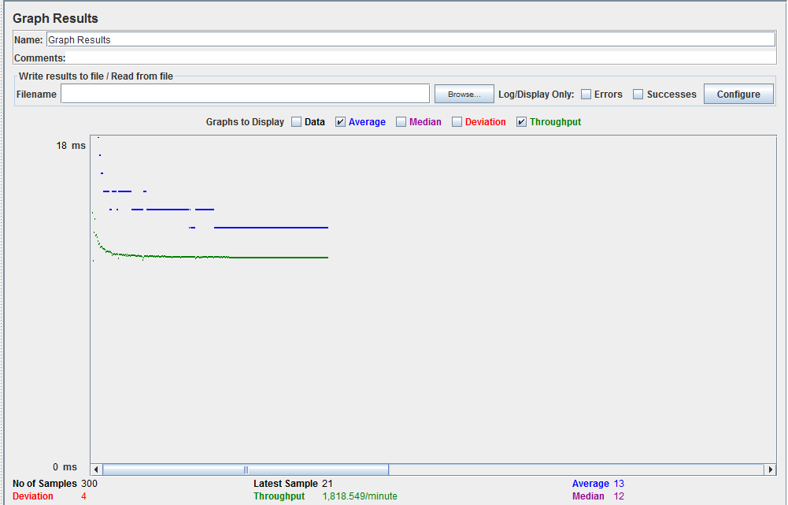

* 1. **400 Concurrent Users**

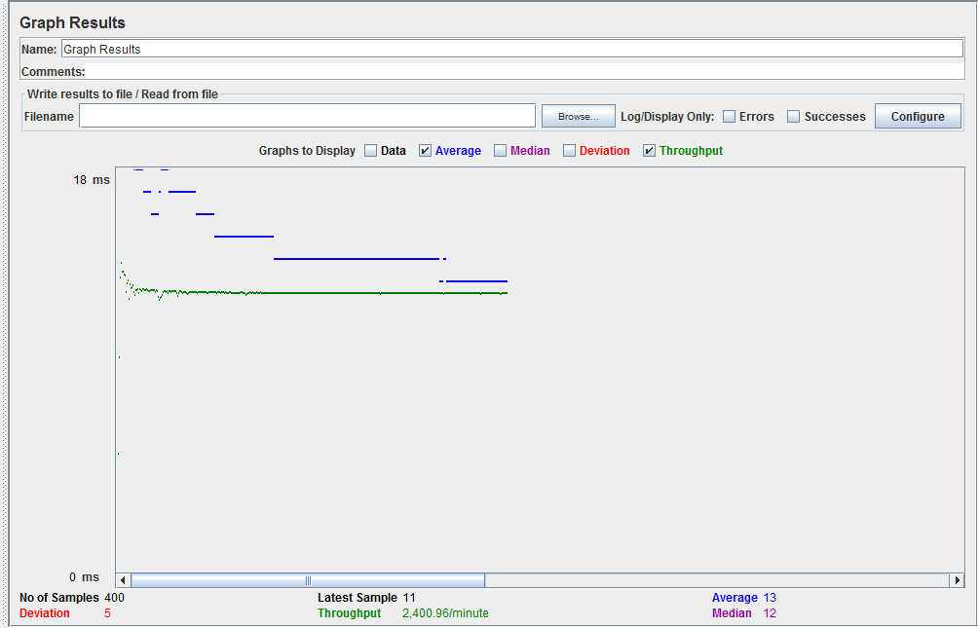

* 1. **500 Concurrent Users**

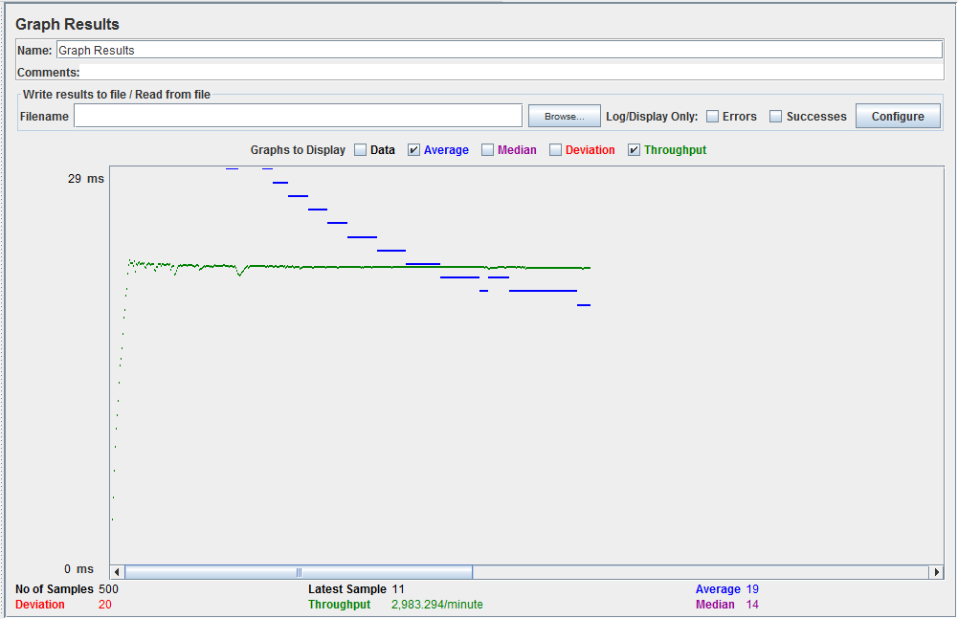

1. **Get all starred files**
   1. **100 Concurrent Users**

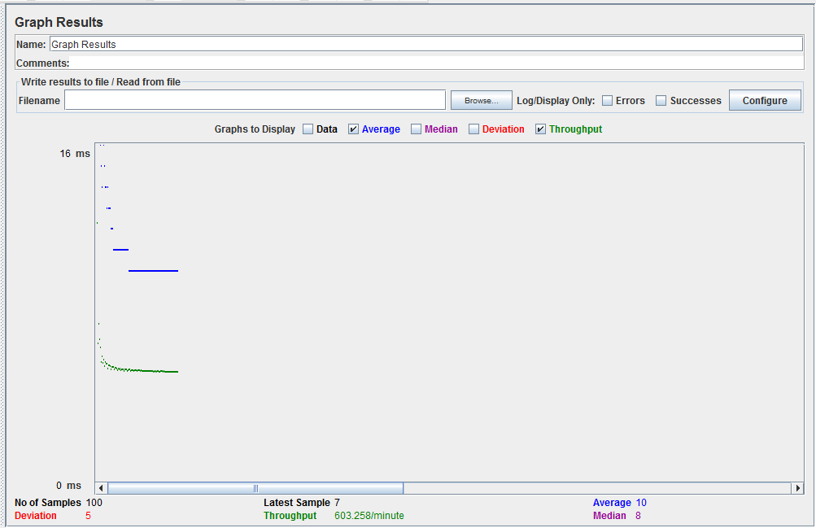

* 1. **200 Concurrent Users**

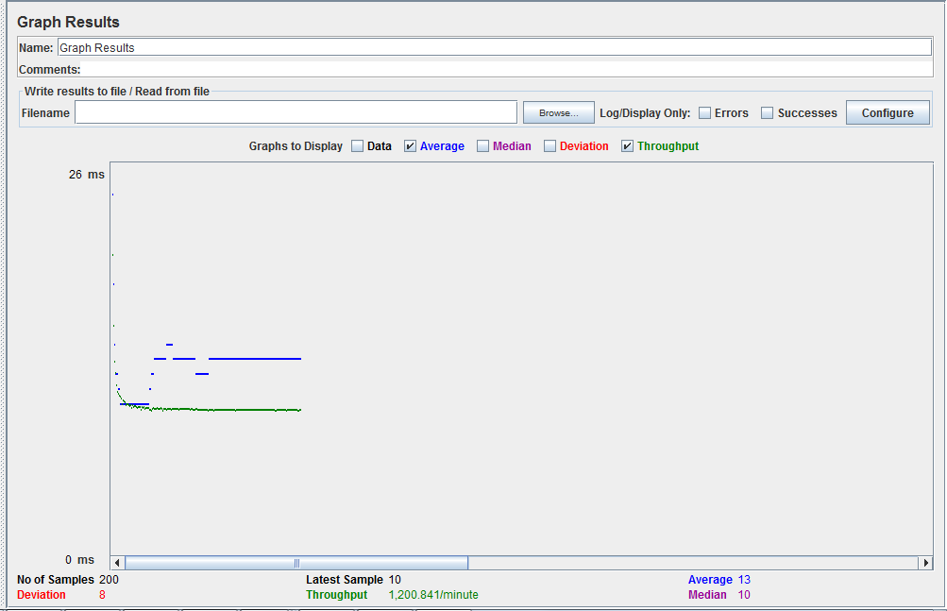

* 1. **300 Concurrent Users**

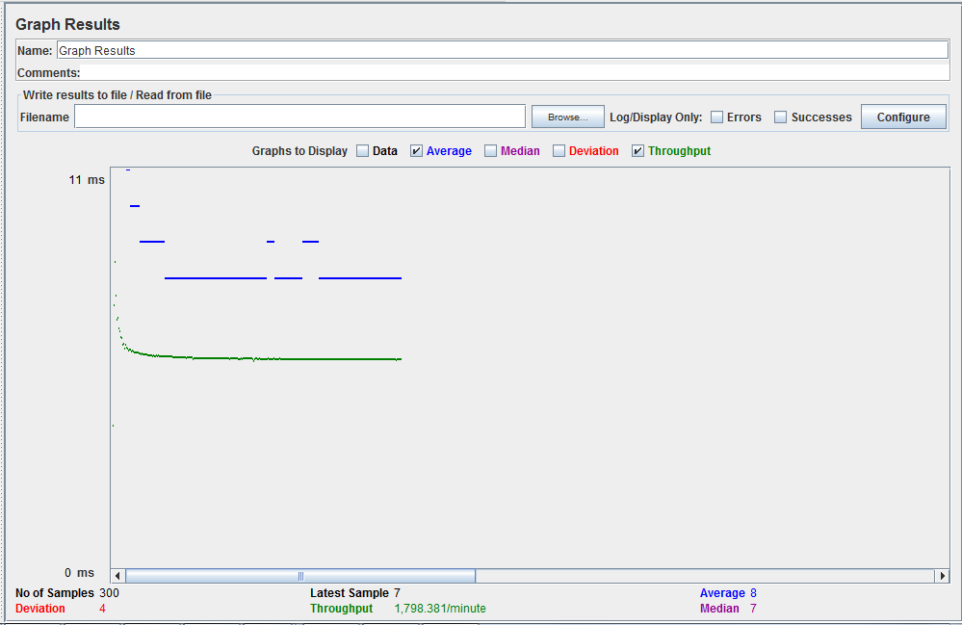

* 1. **400 Concurrent Users**

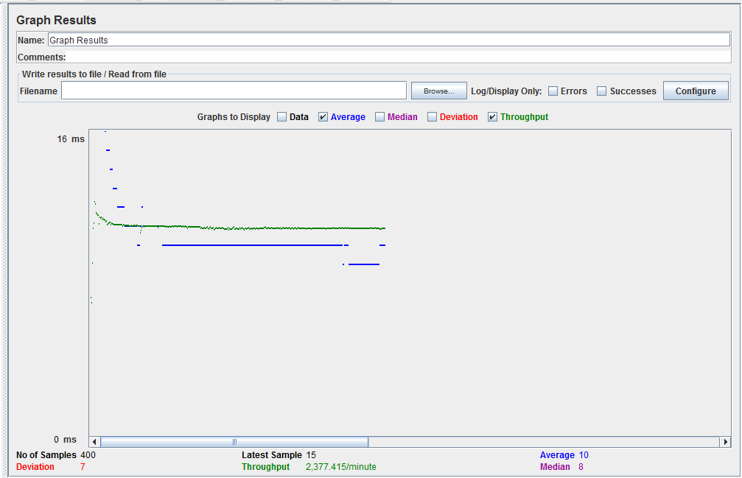

* 1. **500 Concurrent Users**

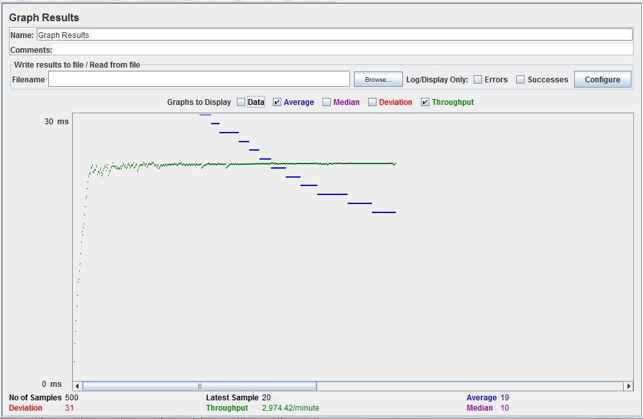

**Custom Connection Pooling:**

1. **User signup**
2. **100 Concurrent Users**

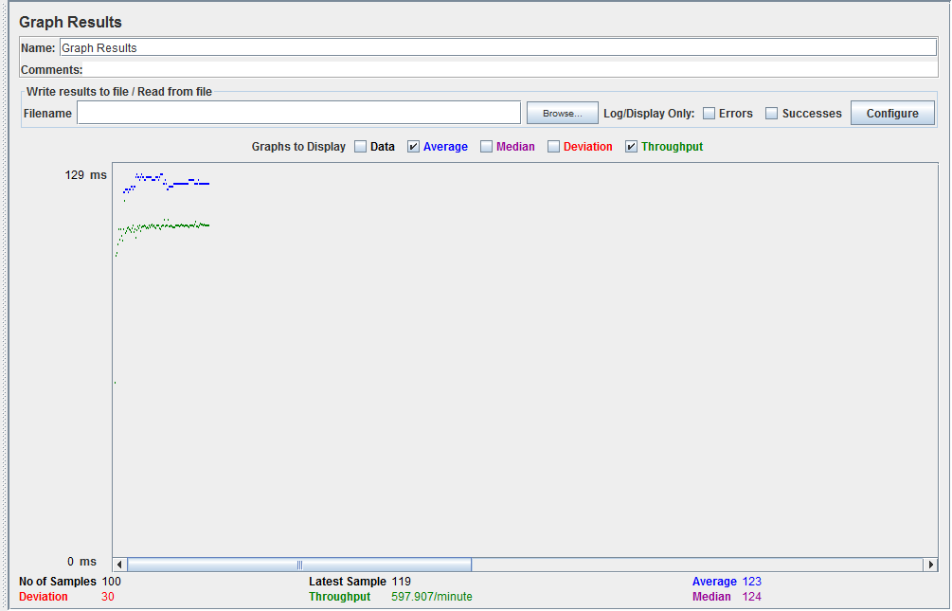

1. **200 Concurrent Users**

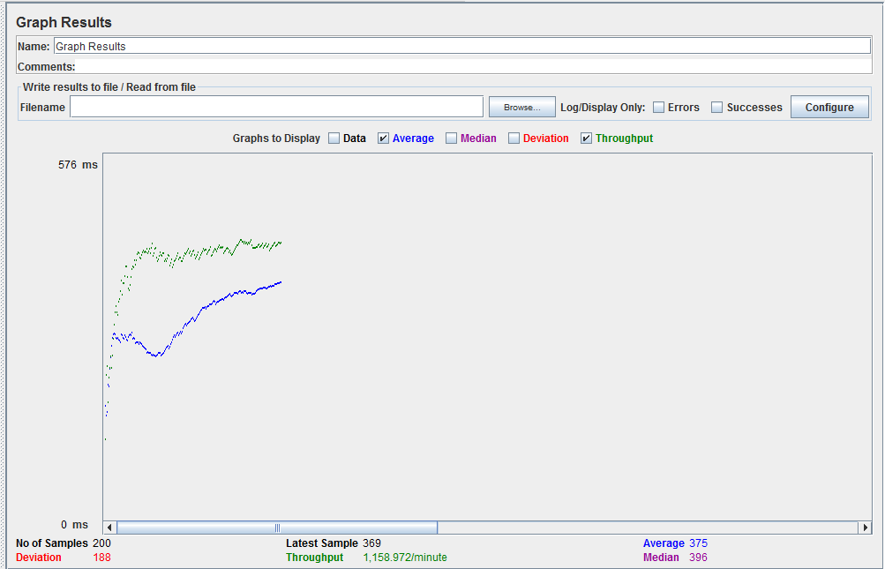

1. **300 Concurrent Users**

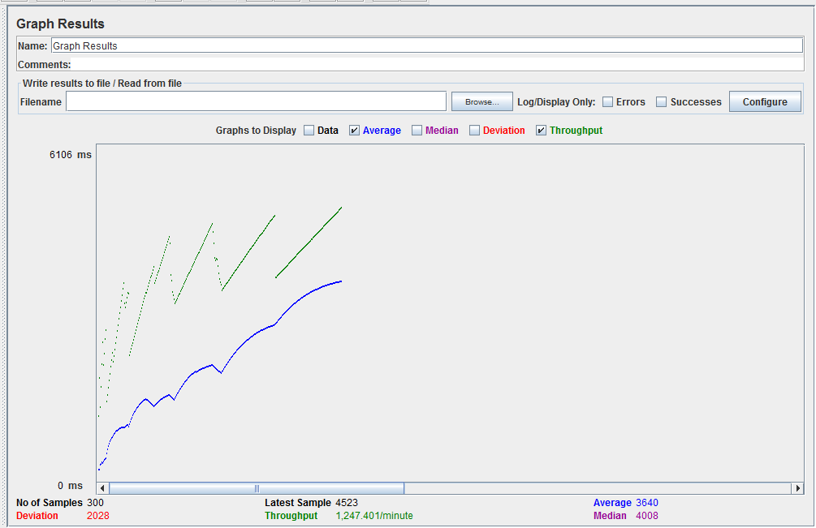

1. **400 Concurrent Users**

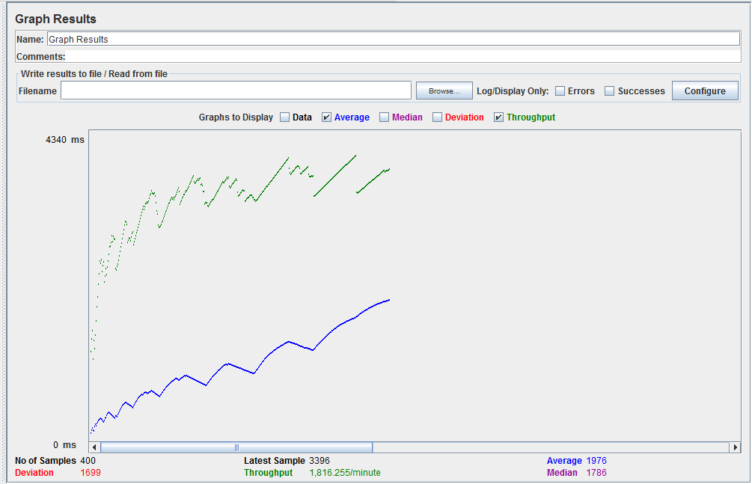

1. **500 Concurrent Users**

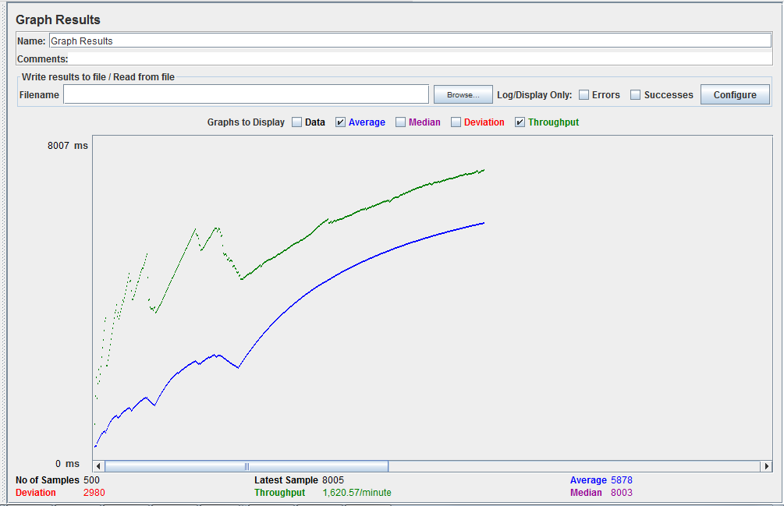

1. **Create a new folder**
   1. **100 Concurrent Users**

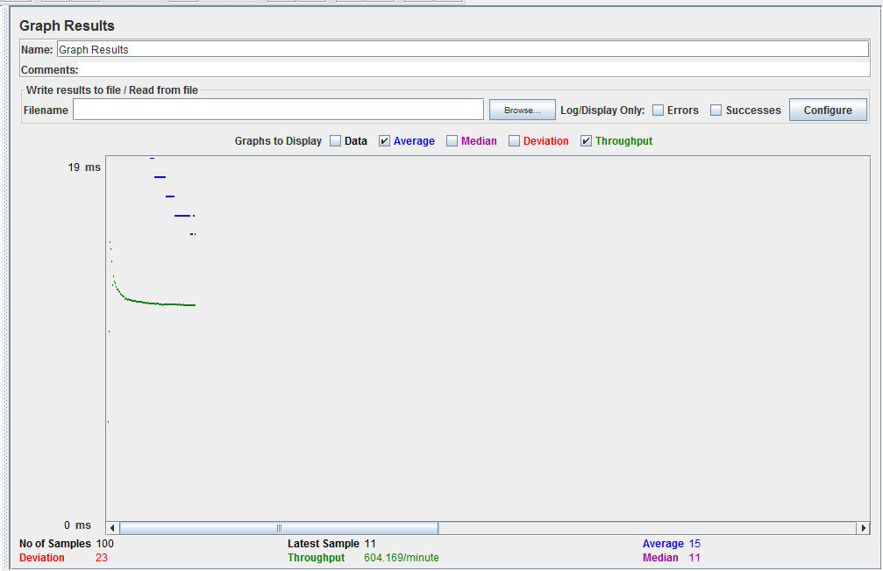

* 1. **200 Concurrent Users**

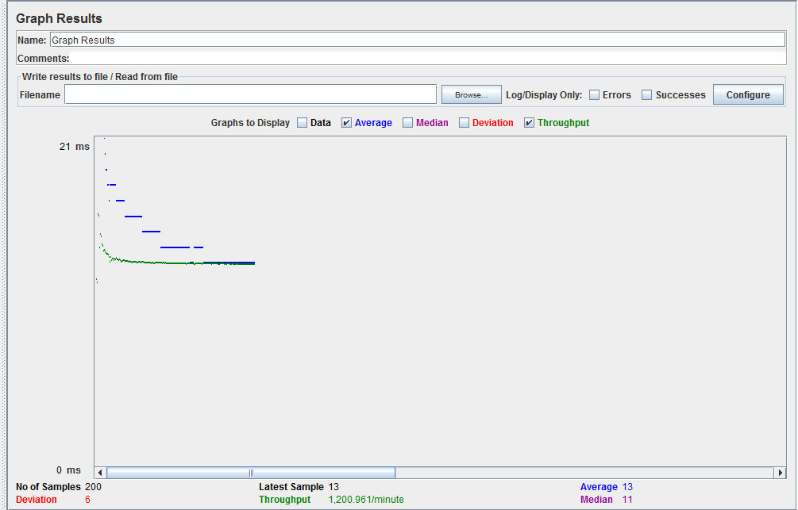

* 1. **300 Concurrent Users**

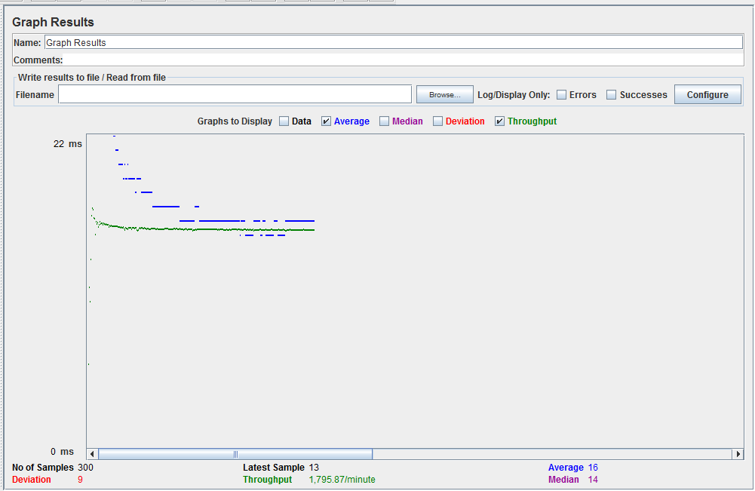

* 1. **400 Concurrent Users**

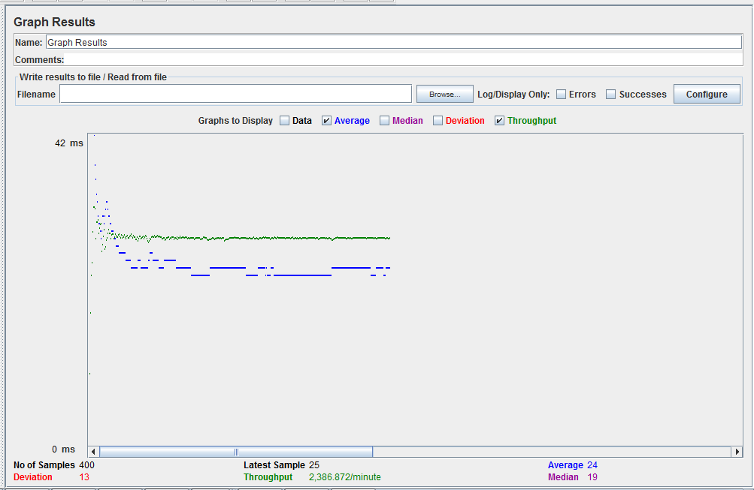

* 1. **500 Concurrent Users**

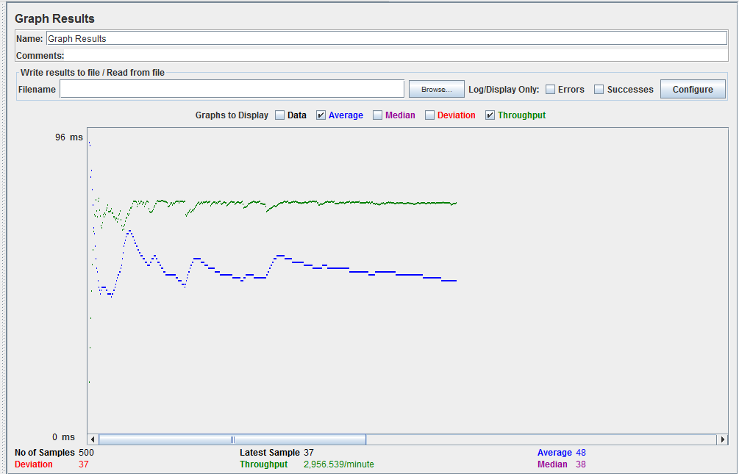

1. **Get all files and folders of a user**
   1. **100 Concurrent Users**

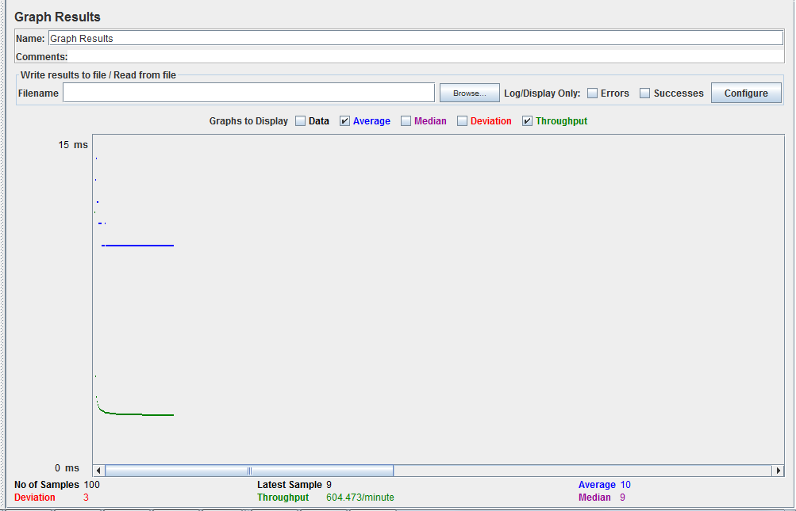

* 1. **200 Concurrent Users**

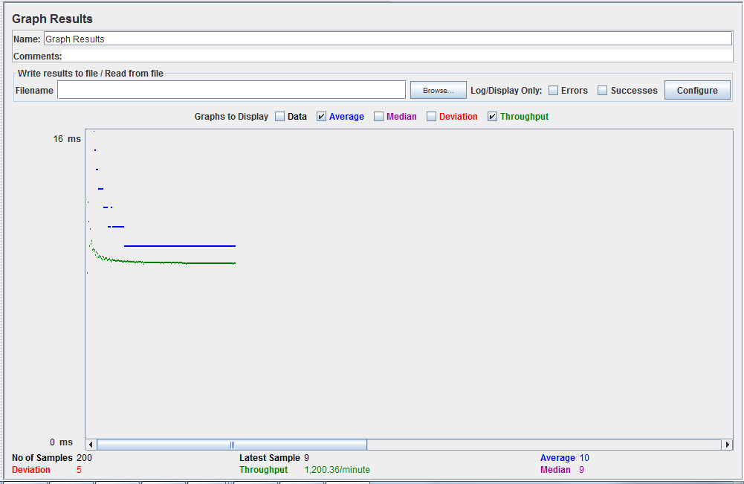

* 1. **300 Concurrent Users**

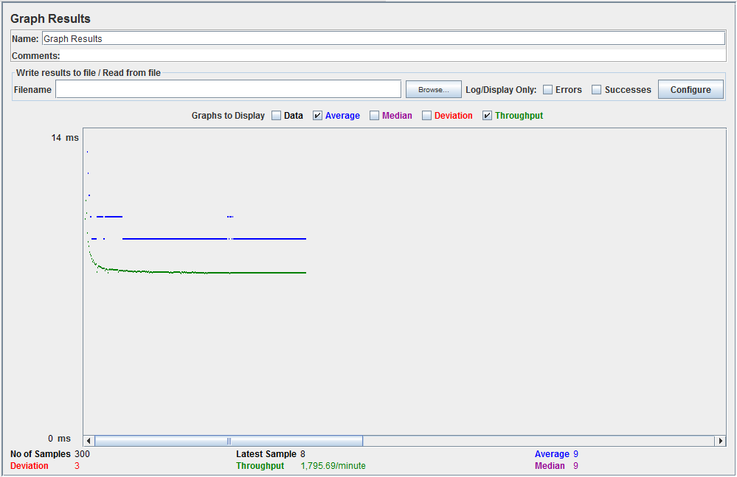

* 1. **400 Concurrent Users**

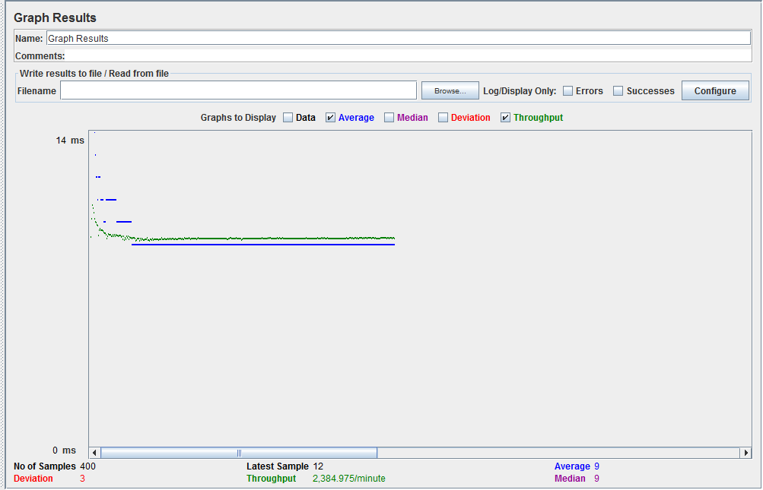

* 1. **500 Concurrent Users**

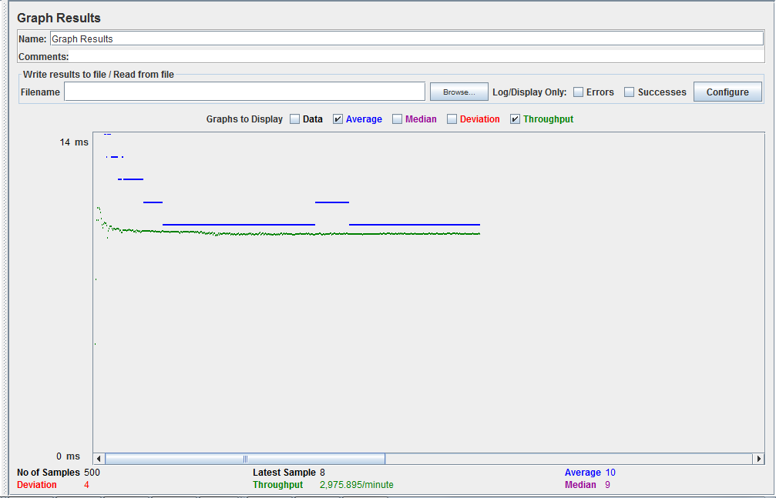

1. **Star a user file**
   1. **100 Concurrent Users**

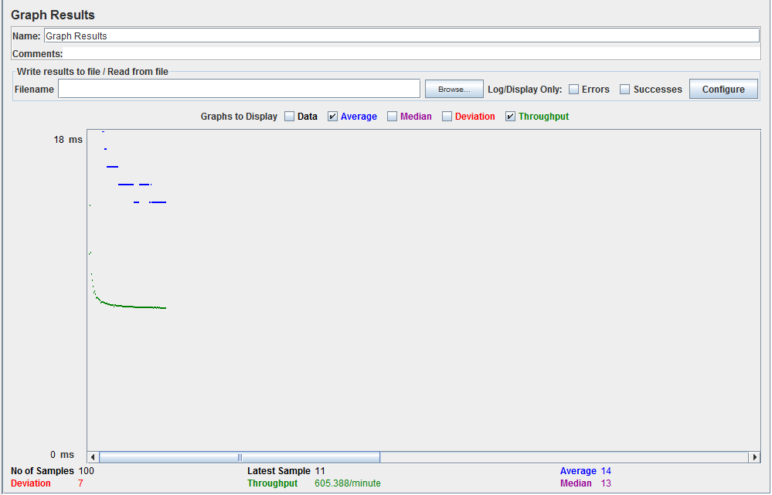

* 1. **200 Concurrent Users**

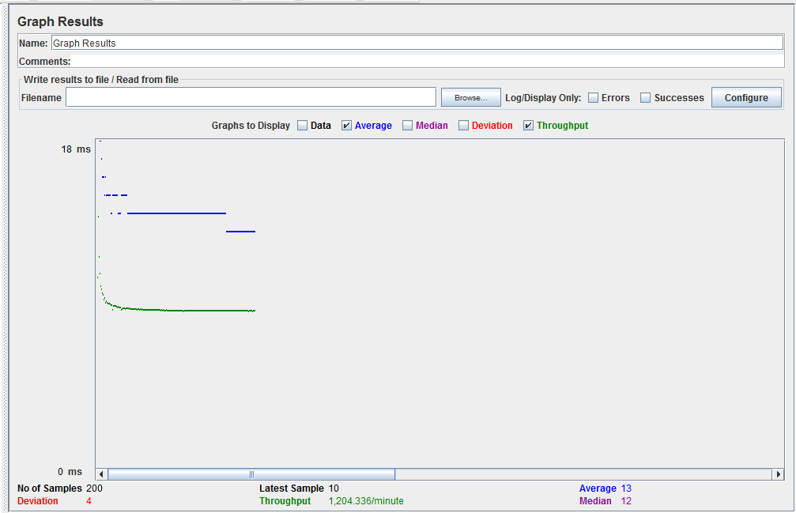

* 1. **300 Concurrent Users**

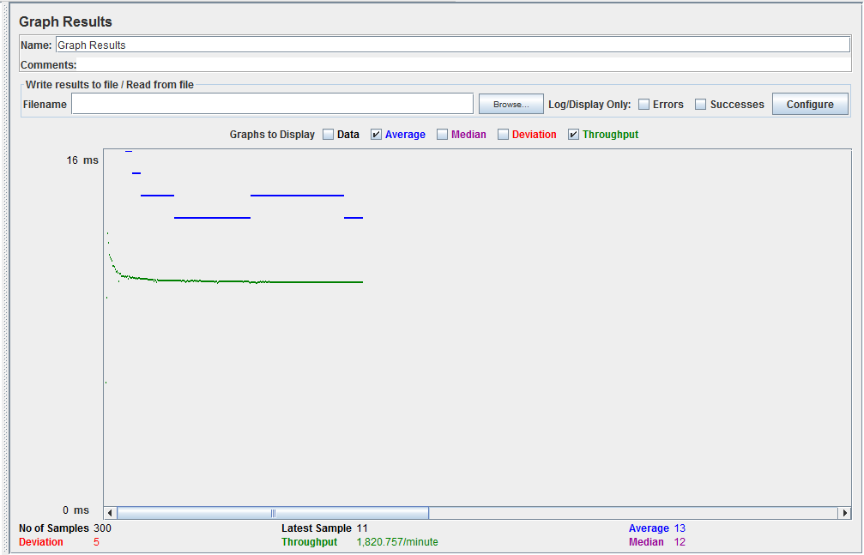

* 1. **400 Concurrent Users**

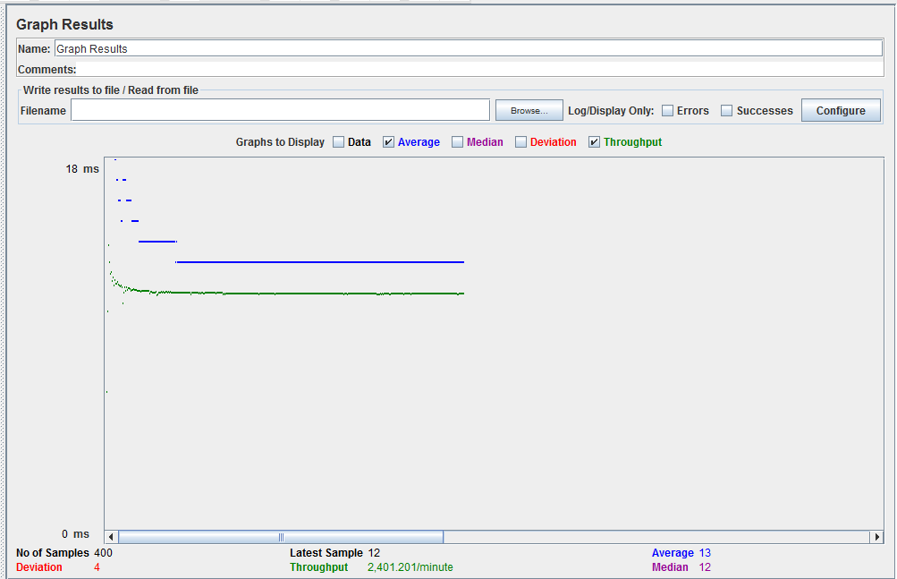

* 1. **500 Concurrent Users**

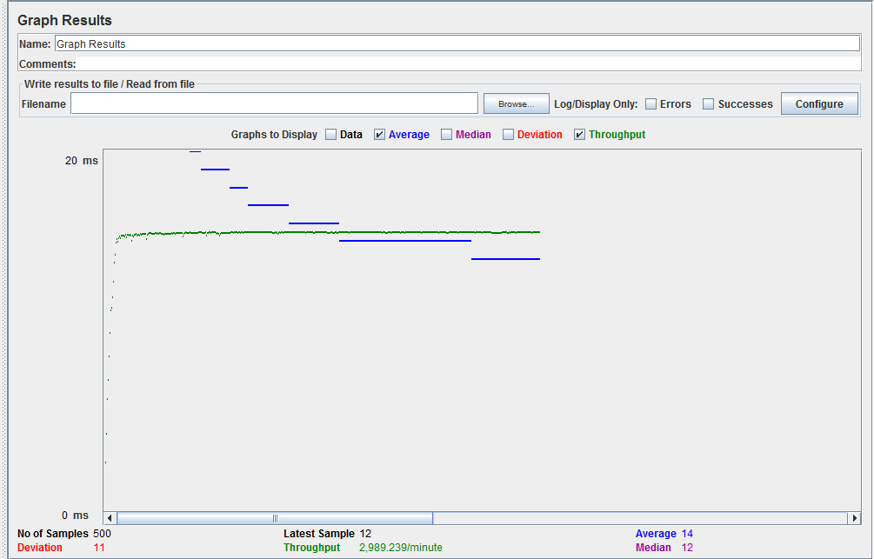

1. **Get all starred files**
   1. **100 Concurrent Users**

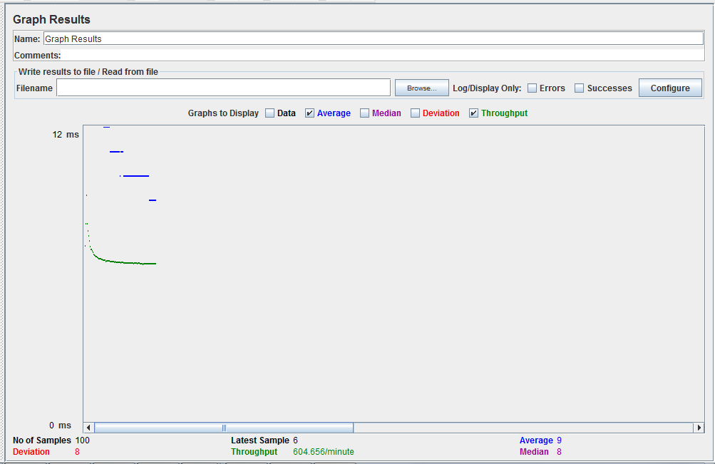

* 1. **200 Concurrent Users**

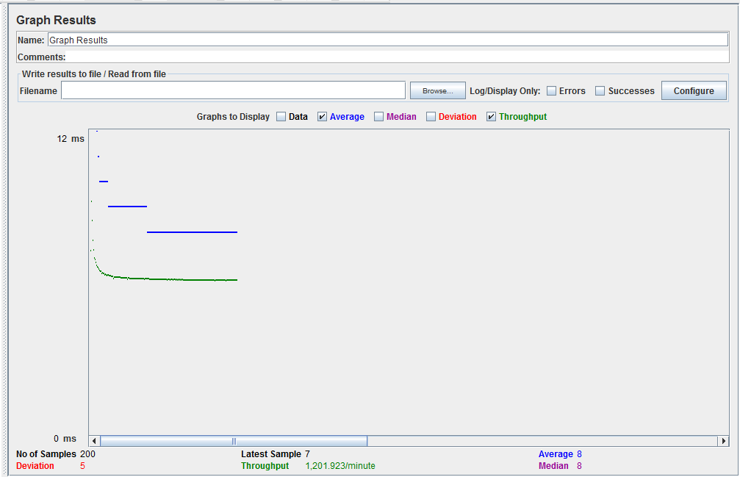

* 1. **300 Concurrent Users**

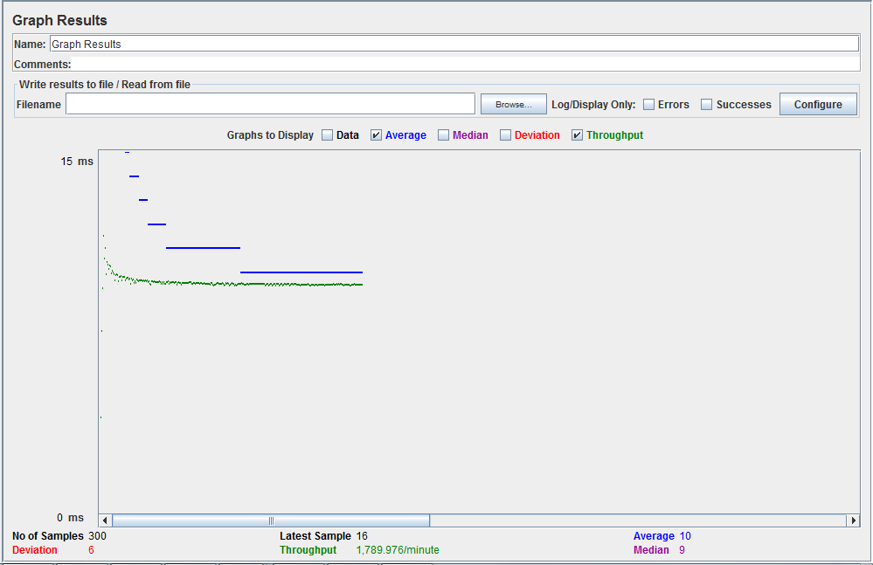

* 1. **400 Concurrent Users**

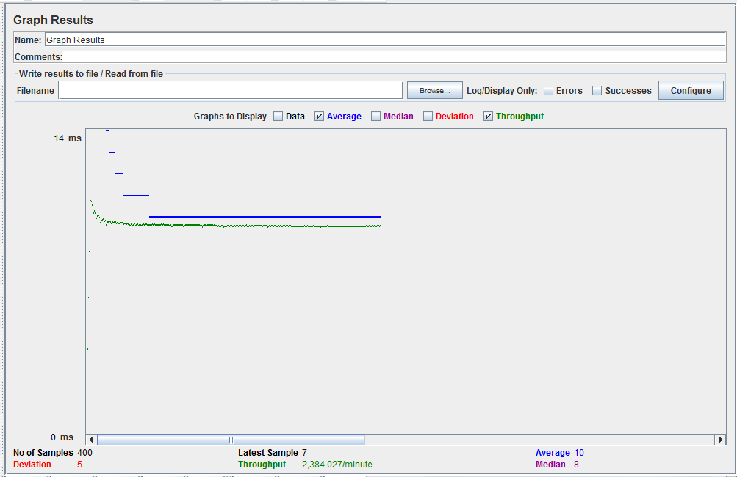

* 1. **500 Concurrent Users**



**Performance Analysis:**

Performance of dropbox server improved after implementing connection pooling. When database provided connection pooling was used performance improved between 30% to 40%. When custom connection pooling was used, the performance improved even better compared to database provided implementation. With custom connection pooling, performance improved around 40%.

Here is the snapshot of implementation of custom connection pooling:

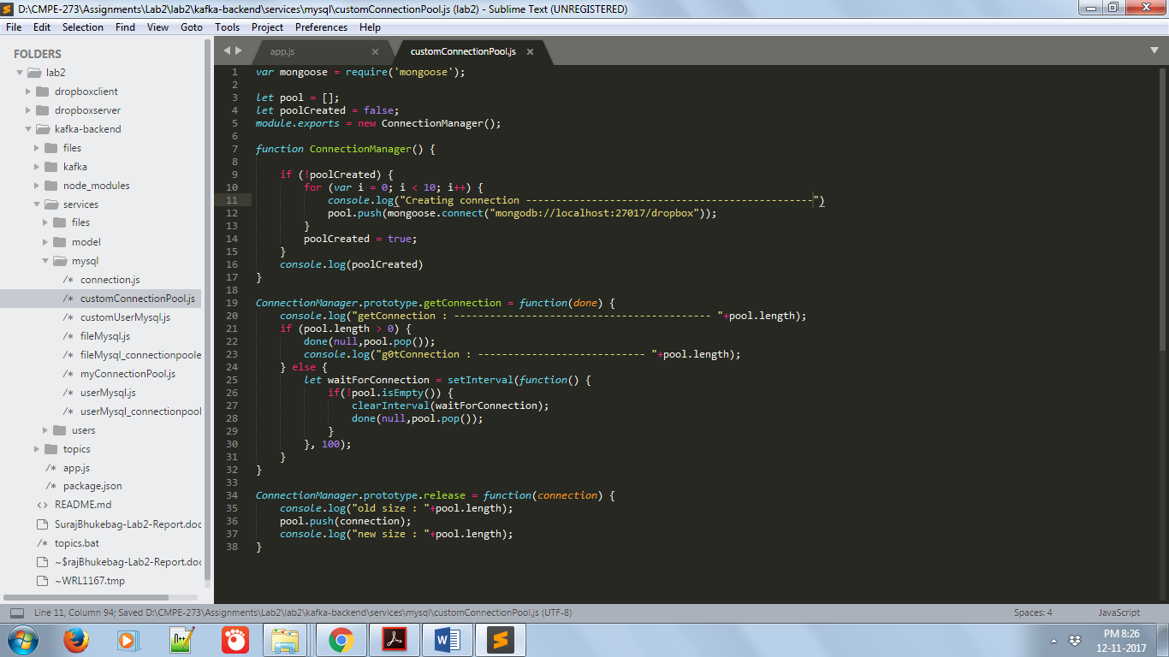

Mocha Testcases:

Snapshots:

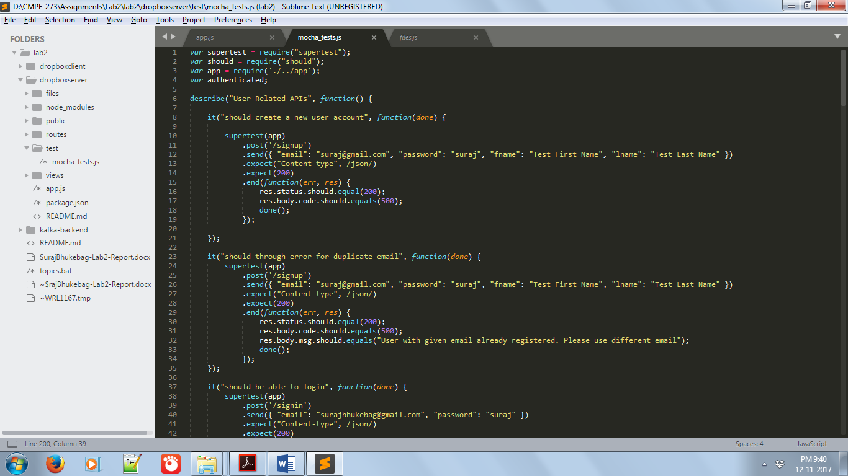

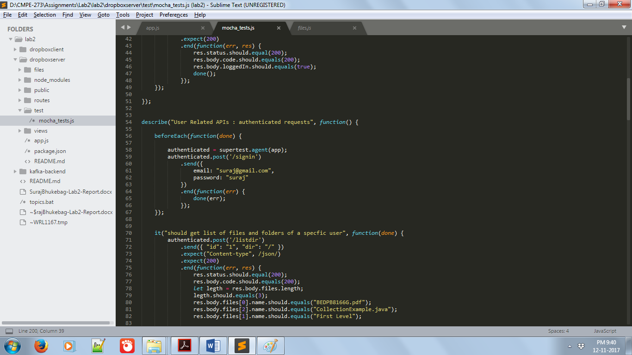

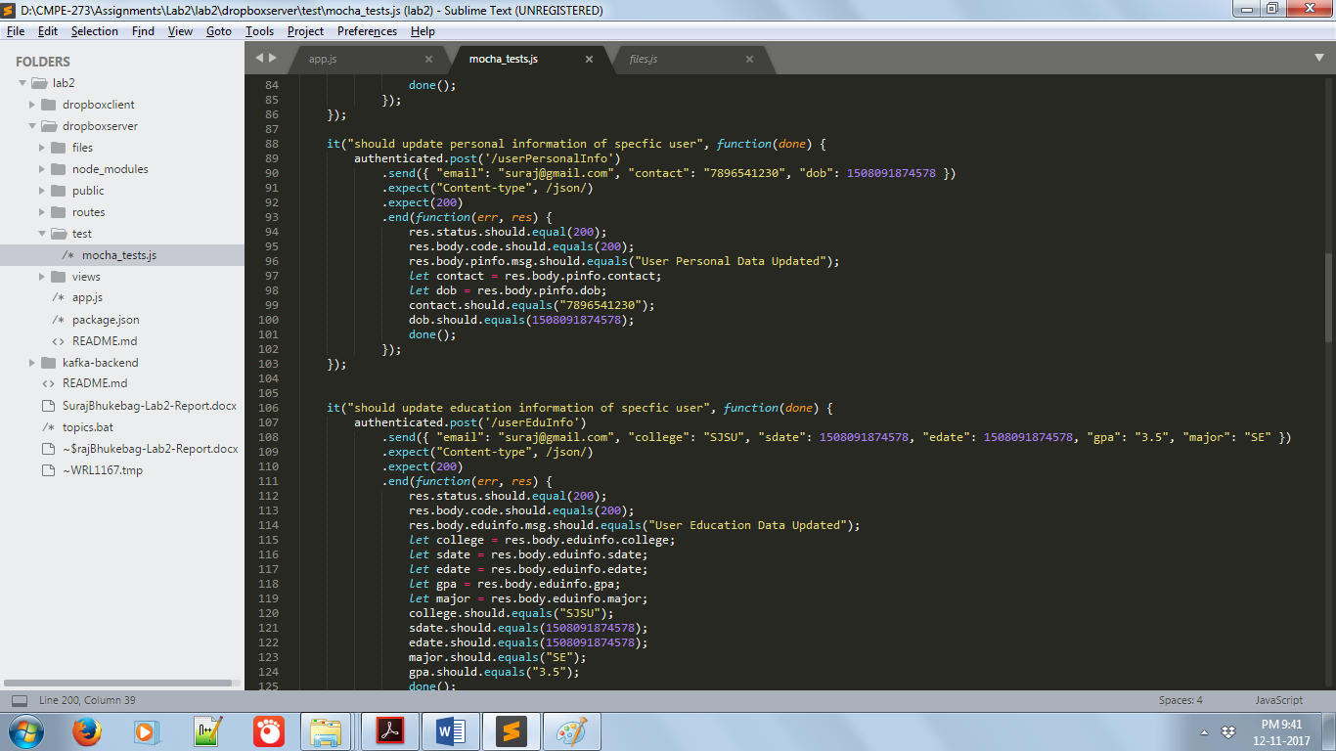

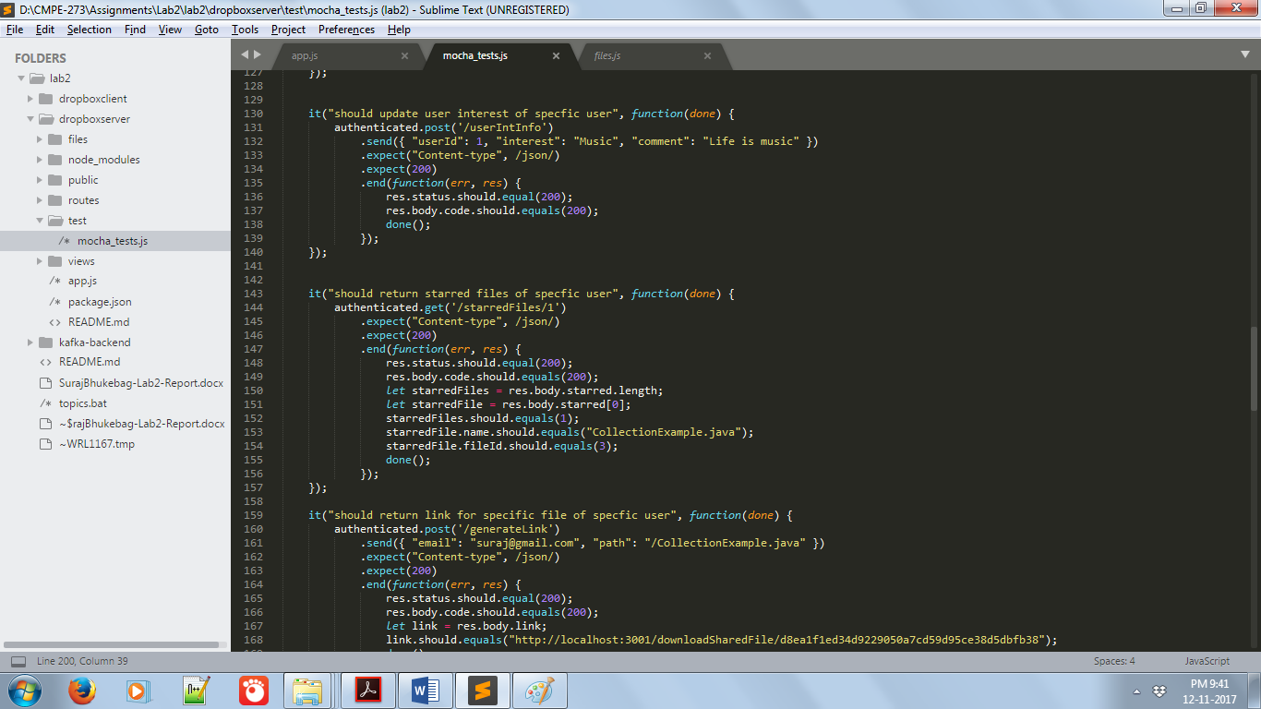

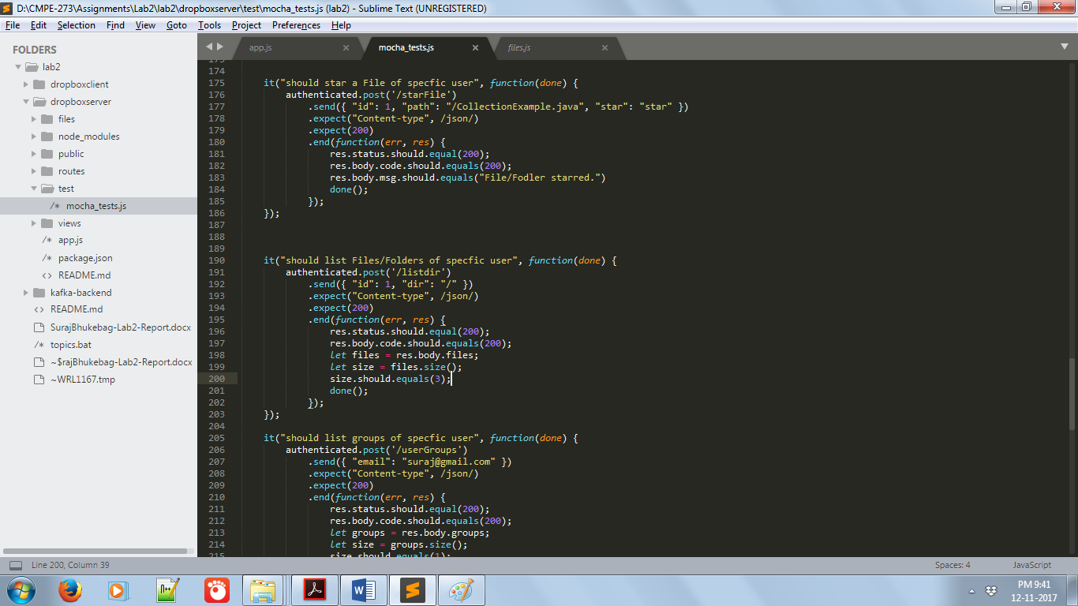

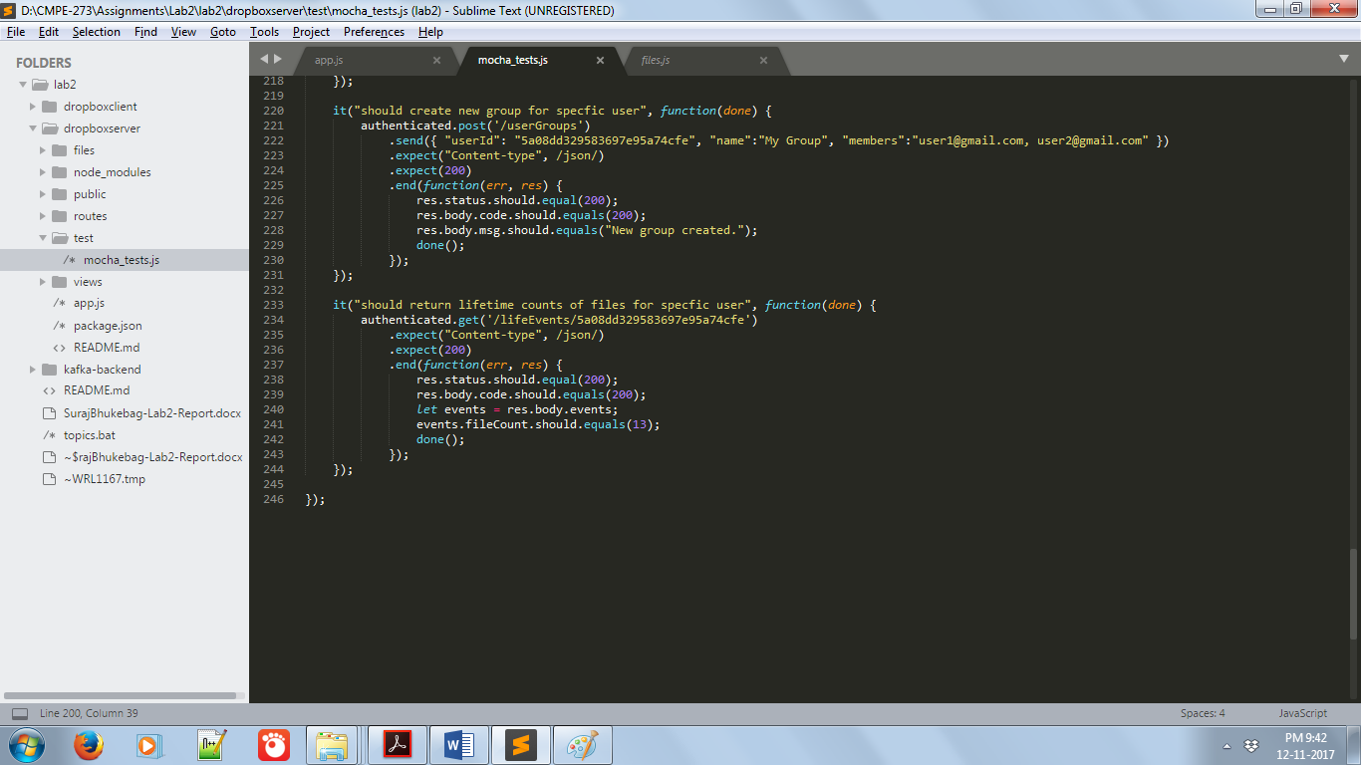

Questions:

1. Passport JS provides different strategies for providing authentication service in the form of package which can be installed using npm. In previous implementation we had written our own strategy for providing authentication. If there was a need of different authentication integration then we would have written all the config and boilerplate code. Passport JS encapsulates this boilerplate code that is required to config different authentication mechanism and provides an easy way for integrating any third-party authentication service or our own implementation. Also, passport make sure all the services are protected by providing serialize and deserialize methods.
2. It was very difficult and tedious to have horizontal scalability for the application when Kafka was not used. Managing sessions on server was difficult which paralysed the horizontal scalability of the application. When Kafka was integrated with the application, the session handling is separated from actual business handling logic. So now the business logic could be replicated on any number of servers and node server will just have to send the message to appropriate topic. Any available server would respond for that message. Kafka messaging helped in realization of horizontal scalability in the application.
3. It is important to decide what data we are going to store in MySql and Mongo DBs. Both have advantages and disadvantages, but the use case directs us to decide what to use. Generally, when we want to have transactional properties for data being stored, then we go for MySql, which offers ACID properties. Usually, banking transactions, e-commerce transactions etc are best suited for relational database such as MySql. When data being stored does not require transactional properties, then NoSql store like MongoDB could be used. Mongo DB provides amazing performance even when there is huge amount of data being stored. If data being stored requires lot of querying then definitely MongoDb is way to go, as accessing data in MongoDB is always O(1). Data is stored in the form of Key and Value pairs. In our application, there is not much transactional data but there is some data that grows exponentially such as User activity, User Files information which are perfect candidates for MongoDb. Data related to user such as User info, education info, personal info which wont change much and is hardly queried. This data becomes perfect candidate for MySql.